Creating Accessible Office Documents

Best Practices for Word, PowerPoint, and Excel

Overview:
This guide combines session notes and a reference resource to help authors create accessible Microsoft Office documents from the start. The goal is to build accessibility into files during authoring — using built-in tools, prioritizing structure over visual formatting, and catching issues before sharing or converting to PDF.

Three core goals:
- Prepare files correctly from the start
- Apply consistent best practices during authoring
- Reduce accessibility issues before documents are shared, posted, or converted to PDF

Why Accessibility Matters
Accessible documents ensure that people with disabilities can access, understand, and use your content. Good accessibility also improves usability for everyone — and makes files easier to maintain, remediate, and convert to accessible PDFs. For many organizations, it also supports legal and policy obligations under the ADA and Section 508.

The most effective time to address accessibility is during file creation. Fixing issues in the source application is far easier than fixing them after export. Building structure upfront reduces the amount of remediation work needed later.

How People Access Documents
People interact with digital documents in many different ways. Common assistive technologies include:
Assistive Technology | Examples
Screen readers | JAWS, NVDA, VoiceOver — read content aloud and allow keyboard navigation
Magnification tools | ZoomText, Windows Magnifier — enlarge on-screen content
Speech input | Dragon NaturallySpeaking, Windows Speech Recognition — control computers by voice
Text-to-speech | Microsoft Immersive Reader, NaturalReader — read text aloud without full screen reader features
Switch devices | AbleNet Big Red Switch, Sip-and-Puff Switch — alternative input for limited motor control
Eye-tracking systems | Eyegaze Edge System — control computers using eye movement
Keyboard-only navigation | Used by people who cannot operate a mouse
Voice input tools | Dragon, built-in voice tools

Practices like using clear headings, providing alternative text for images, writing meaningful link text, and avoiding color-only indicators benefit all of these users.

Universal Accessibility Principles
These principles apply across Word, PowerPoint, and Excel. Applying them consistently is the most effective way to build accessible documents.

- Use built-in styles, layouts, and structure tools — not manual formatting
- Keep content clear and logically organized
- Use a clear and descriptive document title
- Use heading styles to structure content
- Create lists using built-in bullet or numbering tools
- Provide alternative text for images and charts that convey meaning
- Use meaningful hyperlink text that describes the destination
- Do not rely on color alone to convey meaning — ensure sufficient contrast
- Run the Accessibility Checker and follow up with a manual review

Microsoft Word
Structure documents so they are easier to read, navigate, and convert into accessible deliverables.

- Use Built-In Heading Styles: Apply Word's heading styles (Heading 1, Heading 2, etc.) instead of manually formatting text with bold, size changes, or underlines. This creates a navigable structure for screen reader users.
- Use Real Lists and Clear Structure: Use built-in bullets and numbering tools — never manually type bullet characters. Organize content logically with clear sections.
- Write in Plain Language: Keep wording clear and direct. Define acronyms on first use. Avoid jargon where possible.
- Use Descriptive Link Text: Link text should make sense out of context — avoid 'click here' or 'read more.' Include full URLs for print materials when needed.
- Add Alt Text to Meaningful Images: Write concise alt text for images and charts that convey meaning. Mark decorative images as decorative so screen readers skip them.
- Use Accessible Tables: Use tables only for real data, not for layout. Include a clear header row and keep the structure simple. Avoid merged cells and nested tables.
- Set Key Document Properties: Set the document language and title. Use readable fonts with strong contrast. Never rely on color alone to convey meaning.
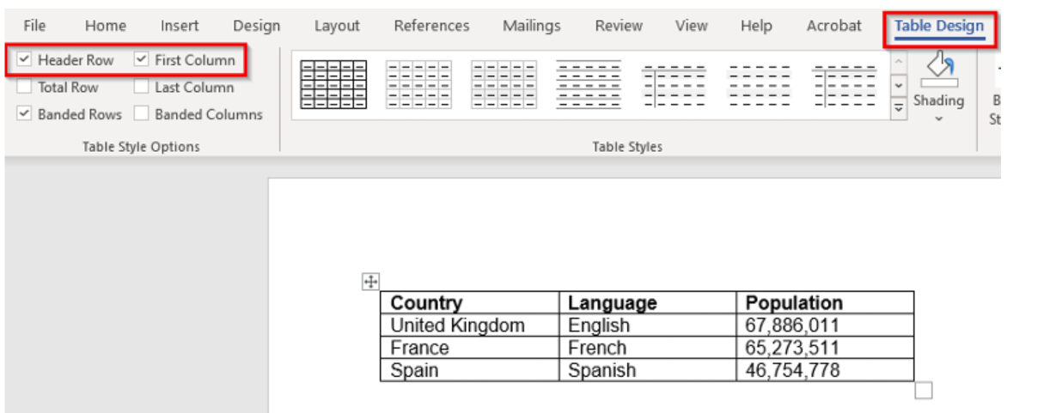
Tables in Word need to have a simple structure and give column header information. To work with a screen reader, Word tables must not contain split or merged cells, completely blank rows or columns, or nested tables.

Microsoft PowerPoint
Create slides that are easier to follow visually and easier to navigate with assistive technology.
- Use Built-In Layouts: Use slide layouts and placeholders instead of free-floating text boxes. This ensures content is picked up correctly by assistive technology.
- Give Every Slide a Unique Title: Meaningful, unique titles help screen reader users navigate between slides and understand where they are in the presentation.
- Keep Reading Order Logical Ensure slide content is read in the intended order, matching the visual flow. Use the Selection Pane to review and adjust reading order.
- Use Readable Text and Strong Contrast: Use legible font sizes, simple backgrounds, and sufficient color contrast between text and background.
- Reduce Clutter: Keep slides focused. Limit excessive text and competing visual elements that make content harder to follow.
- Make Visuals Understandable: Add alt text to images and charts. Explain complex visuals in the slide body or speaker notes so the meaning is not lost.
- Do Not Rely on Color or Animation Alone: Important meaning should never depend only on color, animation, or visual emphasis. Use text labels or other indicators alongside visual cues.
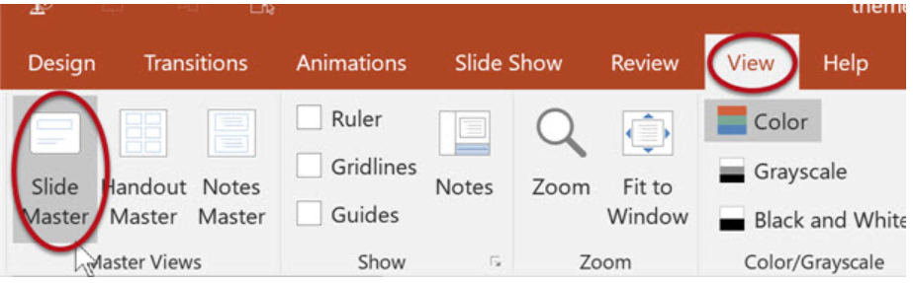
If you create your own slide masters, ensure legible fonts, adhere to color contrast requirements, and make sure to mark any background or decorative elements as decorative.

Microsoft Excel
Excel accessibility depends heavily on structure, labeling, and predictable navigation.

- Use Meaningful Worksheet Names: Rename sheet tabs so users understand each sheet's purpose at a glance. Avoid generic names like 'Sheet1.'
- Keep Layout Simple and Predictable: Organize content cleanly and consistently. Avoid scattered or complex designs that are difficult to navigate.
- Use Clear Column and Row Headers Each data table should have meaningful labels. Use Excel's table feature to define header rows formally.
- Avoid Merged Cells Merged cells cause navigation and reading problems for assistive technology. Use other formatting approaches instead.
- Avoid Blank Rows and Columns for Spacing: Empty rows and columns interrupt navigation and make workbooks harder to interpret. Use cell padding or spacing settings instead.
- Do Not Rely on Color Alone: Use text labels, status columns, or other indicators alongside color to convey information.
- Add Context and Instructions: Include brief instructions for complex sheets or those requiring user input, especially if the layout is not immediately self-explanatory.
- Add Alt Text to Charts and Images: Any embedded chart or image that conveys meaning needs descriptive alt text.
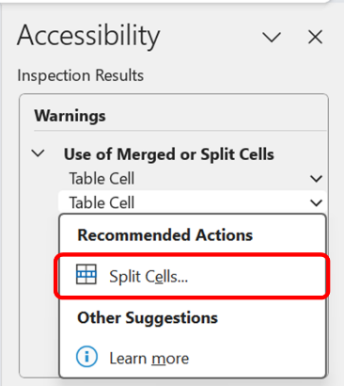
The “Merged or Split Cells” warning in Excel serves as a gentle reminder to evaluate the structure of your tables for optimal accessibility.

Converting Documents to Accessible PDFs
The most reliable way to produce an accessible PDF is to build accessibility into the source file first. Remediating a PDF after export is significantly more time-consuming than fixing the source document in Word, PowerPoint, or Excel. When the source file is properly structured, the export process preserves that structure automatically.

Before You Export
Complete all accessibility work in the source application before converting. Confirm the following are in place:
- All heading styles are applied correctly and in logical order
- Meaningful images have alt text; decorative images are marked as decorative
- Tables have header rows defined and contain no merged or split cells
- Links use descriptive text — not raw URLs or ‘click here’
- Document title and language are set in File → Info → Properties
- The built-in Accessibility Checker shows no unresolved errors

Exporting Correctly from Word and PowerPoint
- Always use File → Save As → PDF: (Word / PowerPoint): In the Options dialog, confirm 'Document structure tags for accessibility' is checked. This preserves headings, alt text, reading order, and language.
- Export (Word on Windows): File → Export → Create PDF/XPS → Options. Check 'Document structure tags for accessibility' and 'Document properties.' Click OK, then Publish.
- Print to PDF: Never use this method. It renders the document as a flat image or untagged content. All structural accessibility features — headings, alt text, reading order — are lost.
- Best for Electronic Distribution (Word for Mac): In the Save As dialog, select PDF format and choose 'Best for electronic distribution and accessibility' when prompted. This is the Mac equivalent of enabling structure tags.

tag structure and produces an untagged, inaccessible file. When saving, confirm that ‘Document structure tags for accessibility’ is enabled in the Options dialog. In Word on Windows, go to File → Export → Create PDF/XPS and click Options to verify this setting before saving.

Exporting Correctly from Excel
Excel exports to PDF differently from Word and PowerPoint. The resulting PDF will not automatically inherit Excel table header structure, so additional verification in Adobe Acrobat Pro is usually required. Before exporting, ensure all sheet tabs are named descriptively, cell A1 on each sheet contains a title or orientation note, and the print area is defined so only relevant content is included in the PDF.
- Define the print area: Page Layout → Print Area → Set Print Area
- Use File → Save As → PDF (not Print to PDF)
- After export, open in Adobe Acrobat Pro and run the Accessibility Checker
- Add or correct table header tags in Acrobat if the checker identifies table issues
- Verify reading order in the Order panel — Excel PDFs often require manual correction

Verifying the PDF After Export
A passing Accessibility Checker in the source file does not guarantee an accessible PDF. Always verify the exported file independently.
Adobe Acrobat Pro Accessibility Checker | Tools → Accessibility → Full Check. Review all failures and warnings. Address Errors first — these represent content that is impossible for assistive technology to read.
Check for Tags | File → Properties → Description tab. Confirm 'Tagged PDF: Yes.' An untagged PDF has no structural accessibility regardless of source file quality.
Check Reading Order | Open the Order panel (View → Show/Hide → Navigation Panes → Order). Step through elements to confirm they read in the intended sequence.
Check Document Language | File → Properties → Advanced tab. Confirm the language field is set. If blank, screen readers may mispronounce or fail to switch language appropriately.
Check Document Title | File → Properties → Description tab. Confirm the Title field is populated. Also verify: View → Preferences → Documents → 'Show: Document Title' is the display setting.
Verify Alt Text | In the Tags panel, locate Figure tags and confirm each has an /Alt attribute. Images without alt text will be announced as unlabeled figures by screen readers.
Verify Table Headers | In the Tags panel, confirm data tables use TH tags for header cells and TD tags for data cells. Use the Table Editor (Accessibility → Reading Order → Table Editor) to review and correct.

Common Issues Found After Export
Even well-structured source files can produce PDFs that require minor correction. The most frequent issues are:
- Table header cells exported as TD (data) instead of TH (header) — fix in Acrobat Table Editor
- Images missing alt text in the PDF even when set in Word — re-apply in Acrobat Alt Text panel
- Document title not appearing in the PDF title bar — set in File → Properties and enable Show Document Title in Preferences
- Reading order does not match visual order — correct in the Order panel
- Language not set — add in File → Properties → Advanced
- Bookmarks missing for long documents — generated automatically from heading styles if export settings are correct; can be added manually in the Bookmarks panel

Testing and Review
The Accessibility Checker catches many common issues, but it is not a complete test. Manual review is always necessary.

Run the Built-In Accessibility Checker
Available in Word, PowerPoint, and Excel:
- Select the Review tab
- Select Check Accessibility
- Review Inspection Results
- Check for Errors
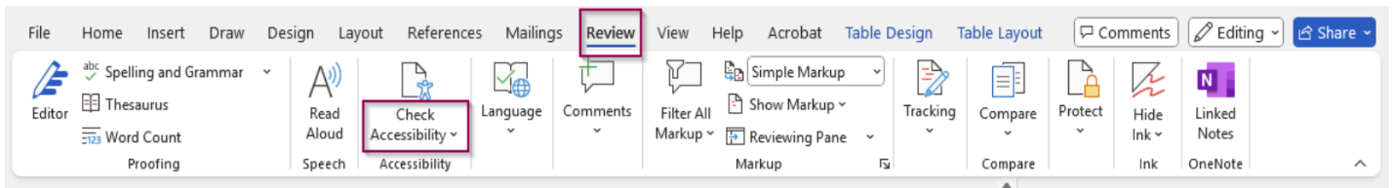

Manual Review Steps
- Confirm logical reading order
- Check heading structure — levels should be sequential and descriptive
- Ensure all meaningful images include alt text
- Verify links are meaningful and make sense out of context
- Confirm data tables include header rows
- Ensure color is not the only way information is conveyed
- Check color contrast for text and backgrounds

Additional Testing for High-Value Documents
- Keyboard-only navigation — tab through all interactive elements
- Zoom and magnification — verify content remains usable at 200%
- Grayscale review — confirm meaning is not lost without color
- Screen reader spot checks — NVDA, JAWS, or VoiceOver on key documents

The goal is not perfection — it's consistent, intentional authoring that reduces barriers for all users.

Quick Accessibility Checklist
Use this checklist before sharing or publishing any Office document.

☐ | Document has a descriptive title
☐ | Document language is set
☐ | Heading styles are used and in logical order
☐ | Lists are created with built-in list tools
☐ | All meaningful images include alt text
☐ | Decorative images are marked as decorative
☐ | Links describe their destination (no 'click here')
☐ | Tables include header rows and are used only for data (not layout)
☐ | Merged cells are avoided
☐ | Color is not the only way information is conveyed
☐ | Color contrast is sufficient for all text
☐ | Accessibility Checker has been run and issues addressed
☐ | Manual review has been completed
☐ | Reading order has been confirmed (especially in PowerPoint)
☐ | PDF exported using Save As — not Print to PDF
☐ | ‘Document structure tags for accessibility’ was enabled during export
☐ | PDF is tagged (confirmed in File → Properties → Description)
☐ | Acrobat Accessibility Checker run on the exported PDF and errors resolved
☐ | Reading order verified in Acrobat Order panel

Accessibility Resources

- Section 508 Authoring Guidance
- Document Accessibility Checklists (SSA)
- Microsoft: Create Accessible Office Documents

