Building an Accessory Dwelling Unit (ADU) or
Junior ADU (JADU) in [Jx Name]

Invest in your family and community and build an ADU
From space for your loved ones to building your retirement through renting,
an ADU will grow with you and your family over time.
 |  | 
Housing Family like adult  children, parents or loved ones with special needs. | A Home as You Age for  caregivers or aging adults who want to downsize. | Rental income  for retirement, savings  or a rainy day.
 |  | 
Property value and  future sales price increase  with an ADU. | Extra Hands on your  property can be helpful for  upkeep, daily tasks and more. | Housing community from  workers to young families  looking for a local home.

What is an Accessory Dwelling Unit?
Accessory Dwelling Units (ADUs) come in many shapes and sizes but are always a self-contained home that is legally part of the same property.
Both ADUs and JADUs must have their own entryway and be at least 150 square feet in size. Both must be rented for 30 days or more—no short-term rentals are allowed.
ADUs can be attached or detached and may be brand-new construction or converted from existing buildings or structures. ADUs can be up to [1,200] square feet and must have their own bathroom and a full kitchen. Shared walls and floors must be rated for one-hour fire resistance.

Junior ADUs (JADUs) are conversions no more than 500 square feet, located within an existing home (including an attached garage). JADUs can share a bathroom with the main home and need at least a sink, a counter, and smaller appliances. The owner must live in the main home or the JADU.

ADU Types
JADUs and internal conversions usually cost less to build.
 |  | 
Detached  A new freestanding structure separate from the main home (may be site-built or prefab/modular – see below). | Attached  A new structure (may include converted space) sharing at least one wall with main home. | Multifamily  A detached, attached, or conversion ADU on a multi-family property (duplex, triplex, apartment building).
 |  | 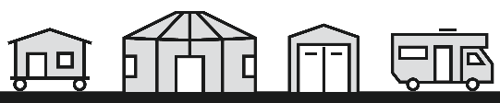
Conversion  Converted existing space in the main home or on the property (bedroom, basement, garage, other buildings). | JADU  A smaller conversion within the main home or attached garage, up to 500 square feet with at least an efficiency kitchen. | What’s Not an ADU?  RVs, tiny homes on wheels, yurts, and storage structures are NOT considered accessory dwelling units.

Construction Types
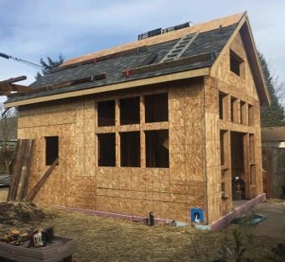 | Site-built  Traditional construction, highly customizable and built on-site. Also known as stick-built. | 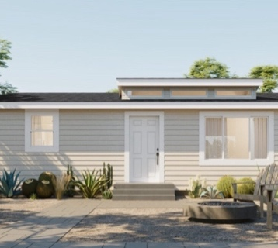 | Prefab/modular  Partially or mostly built in a factory, then shipped to your property and assembled or placed on a foundation. Also known as manufactured.

Overview of Building an ADU

 | Step 1 Get Started 1-3 months  - Think about what you want and your goals and concerns.  - Look for inspiration on [ADU website] and view floorplans and photos.  - Make an informal sketch of your property with property lines, buildings, trees.  - Estimate costs and possible rental income using our [ADU Calculator].
 | Step 2 Learn the Rules 1-3 months  - Learn about your property and any restrictions with the [tool name] or by contacting [Planning].  - Learn the rules and what you can build on your property.  - Meet with [City/County] staff to understand any rules that may apply to your ADU.  - Adjust your budget as needed and create a plan for financing your project.
 | Step 3 Design Your ADU 1-6 months  - Consider using a [pre-approved/pre-reviewed ADU Plan] to get a jump start.  - Hire professionals like an architect, designer or licensed contractor.  - Create your initial design and discuss it with staff. For appointments email [Planning].  - Finalize your design for permitting. Your architect, designer, or contractor will help.
 | Step 4 Apply for Permits 1-6 months  - Submit your [zoning/planning review form] and fees to [Planning].  - Prepare your [building permit application] and all [submittal requirements].  - Submit your building permit application [by email or in person] to [Building] and pay initial fees. Complete applications are reviewed in [60] days.  - Revise your application if needed. Expect [two] weeks for review. Email [Building] for updates. Pay any remaining fees and pick up your building permit.  - Apply for an address for your ADU. Submit the address assignment form to [Building].
 | Step 5 Construct Your ADU 6-12 months  - Ensure all funding is in place before you start construction.  - Monitor construction (typically 6-12 months) by checking in regularly with your contractors, making decisions about materials as needed, and ensuring inspections are moving along.  - Schedule inspections throughout construction. Email [Building] or call/email [555-555-5555]. Your contractor will do this for you.
 | Step 6 Move In  Once your ADU has passed the final inspection it’s ready for move-in!  [ADUs require a certificate of occupancy before move-in].

ADU Building Process: A Step-by-Step Guide
We are here to help you through your ADU building process. Learn more about each step on the following pages and reach out to us with your questions. Contact Information is provided at the end of this handout.

Financing your ADU
Your budget is one of the most important parts of your ADU project. Before you start planning, think about the overall costs of building an ADU. Talk to [Department/Organization] about your budget and to learn how you can save money. Use the [ADU Calculator or other tool] early on to estimate your costs and possible rental income to plan your long-term budget. Regardless of how much you spend, an ADU is a great investment for your property and your family. The extra space provides flexibility over the years, and rental income and increased property value puts cash back in your pocket.
[Financing/Grant/Loan] Programs
[City/County Program Description and contact info].
CALHFA Grant The California Housing Finance Agency (Cal HFA) ADU Program has provided grants of up to $40,000 to qualified homeowners for the reimbursement of ADU pre-development costs, including impact fees. To qualify, a homeowner must be low or moderate income.

Step 1 Get Started

Building an ADU can be overwhelming. Reach out to [Dept/ Org] for project assistance early on and throughout the process.
The [ADU Website/Organization] has resources to support you.
- [ADU Guidebook]: A step-by-step guide for building an ADU.
- [ADU Calculator]: Get a rough estimate of costs, fees, and rents.
- [Pre-approved/Pre-reviewed Plans]: Look at plans including prefab ADUs.
- [Other Resources]: [Description]

Step 2 Learn the Rules

Learn what you can build on your property. [City/County] staff is here to help. Email [Planning], visit the [Planning Counter/Permit Center] in person or make a virtual appointment.

ADU Rules and Regulations
According to state law, you can build up to an 800 square foot ADU, as long as rear and side setbacks are at least 4 feet, and it is not above 16 feet tall. No room behind or next to your main home? You can build it in your front yard. More information about what you can build is in the Standards and Rules [Appendix/Handout].
- Rentals: Short-term rentals (less than 30 days) are prohibited for both ADUs and JADUs.
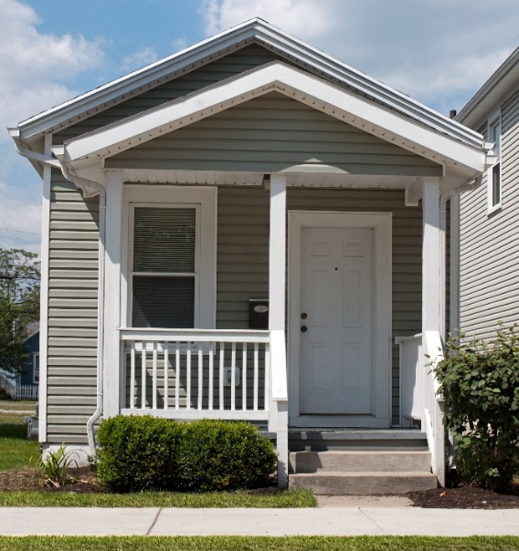
- Sale: Selling ADUs separate from the main home is generally not allowed. [If your jurisdiction allows separate sale replace this bullet with what applicants should know or how to learn more.]
- Homeowner and Neighborhood Associations (HOA): Cannot prohibit or unreasonably restrict ADUs, although they may require certain standards. May not prohibit renting an ADU.
- Junior Accessory Dwelling Units: JADUs are a special type of conversion located within an existing home, including an attached garage. JADUs cannot be sold separately the owner must live either in the main home or the JADU. Owners must complete the [deed restriction form] and record with the [County Clerk].

Utilities and Special Circumstances
- Utilities: ADUs converted from existing space and JADUs do not require connection fees or capacity charges, unless the ADU or JADU is built alongside a new single-family home. Even when new connections are not required, homeowners may be required to upsize service and/or meters to meet capacity requirements. New electric and gas connections or electrical upgrades can add time and cost. Reach out to your utility providers early in the process to find out about connection fees and timelines.
- Soils Report: A soils report is required for all new construction.
- Fire Safety: Common walls between dwelling units must have one-hour fire resistive construction. Fire sprinklers are only required for ADUs if required for the main house. Talk to [City/County] staff and [Fire Department/Agency] to see if modifications are required.
- Energy Code: New, detached ADUs must provide solar energy systems. Solar is not required for ADUs under 500 square feet or if the solar would generate less than 1.8 kilo watts.
- Flood or Hazard Zones: Hazard requirements depend on property elevation and location. Talk to staff early to find out if additional requirements are needed for your project.
- Historic Preservation: There may be additional standards for historic properties [include any resources or forms]. These standards do not apply to ADUs that are up to 800 square feet, 16 feet tall, and with four feet side and rear yard setbacks.

Step 3 Design Your ADU
Although you can build an ADU as an owner-builder, we strongly recommend hiring a professional architect/designer and contractor to help you through the process.
Although it might seem less expensive to do it yourself, an ADU is a big project and mistakes can be costly. Working with professionals is often the key to making sure your ADU meets building codes and standards. A professional may also help you get your ADU permits approved more quickly.

[“Pre-approved/reviewed”] ADU Plans
[Get a head start with ready-made plans!]
[Explore available ADU plans online]
[Browse plans for detached ADUs and prefab ADUs including plans that can be downloaded by the public at no cost. Skip the design process and get a head start on permitting. Plans will still need to be customized to your property.]

Garage Conversions
Homeowners can convert legally built structures (garage, barn, art studio) into an ADU.
JADUs can be converted from an attached garage (but not detached). If you demolish your garage or other enclosed structure and build an ADU in its place, the ADU can be in the same footprint if it’s the same size and height of the structure it’s replacing. Demolition permits for an existing detached garage can be processed at the same time as the ADU. Garage conversion ADUs will require moisture barriers and other design elements to meet building codes.

Step 4 Apply for Permits


Meet with the [City/County]
Staff can help identify issues before you submit your application.
Once your ADU plans are finalized, you should talk to [City/County] staff to make sure you are submitting a complete application. Submittal requirements can be found [submittal requirements handout]. Reach out to the agencies that provide vital services like water, sewer, gas, and electricity to see if their requirements will impact your design, cost or timeline.

Review Process
The ADU permitting process can be complicated. Reach out to [Dept/Org] for help.
The permit review process starts when your designer or contractor submits your application materials.
- [Zoning/Planning] Review: Confirms you can build an ADU on your property. Submit [form] in person at the [Permit Center] or by email to Planning.
- Building Permit Application: Submit a complete [building permit application] and all [submittal requirements] in person at the [Permit Center] or by email to [Building].
- Plan Check: Once a complete application is received, Building, Planning, and Public Works [others] review your construction plans. Outside reviewers may include Fire, Sanitary District, and School District [others]. Expect [60] days for the first review and [two] weeks for resubmittals. Contact [Building] for updates.

ADU Project Fees
ADUs can be charged a variety of fees from the [City/County], State, and other agencies.
These include permitting, development impact, and utility fees. Some fees are based on the details of the project while others are fixed. Development impact fees help pay for community infrastructure like parks but are not charged for ADUs under 750 square feet or attached ADUs. Surprisingly, the [City/County] does not control many of the most expensive fees, like school and water fees. Speak with [Planning] and utility service providers for more info. Many fees are updated annually. Check [here] for updates.
Permit, Impact & Utility Fees | Information Fee Amount or Calculation
ADU [Zoning/Planning Application] Fee | - [$$$] for typical review unless you have a complicated site or project (Fiscal Year [23-24]).
Average Building Permit/Plan Check Fees | - [Describe how fees are assessed. Include a range or examples from past projects.]  - [$$$] for a $100,000 ADU  - [$$$] for a $300,000 ADU
Other [City/County] Department Fees | - Public Works and other agency fees may be required. Talk to [Building] for more info.
Development Impact fees | - No city impact fees for ADUs under 750 square feet [others?]. Other ADUs pay Parks and Trail and Stormwater fees.
School fees | - [$$$]/square foot. Check [here] for updates.  - No school fees for ADUs less than 500 square feet.
Fire District | - [$$$] for plan review and inspection. For more information on the fee, check [here].
Utility and Connection Fees | - For information about capacity charges, contact [Building] and reach out to your utility providers to confirm. See Contact Information below.

Unpermitted ADUs
If you constructed an ADU without permits, you may want to consider legalizing it.
Doing so can reduce liability and risks to occupants, increase property value, and provide peace of mind. Reach out to [Dept/Org] for assistance and to learn more. No fines or enforcement will result from reaching out. Owners can request a delay of citations for unpermitted ADUs, as long as there are no safety issues, until 2030. An unpermitted ADU built before 2020 can be legalized, even if it is in violation of building standards, state ADU Code, or local ADU ordinances, unless the ADU is deemed substandard or there is a health and safety hazard.

Step 5 Build Your ADU

Hiring your Contractor

The California Department of Consumer Affairs can help you find a contractor. They have resources on hiring, checking license status, negotiating a clear contract, and resolving disputes. Before you hire your contractor, make sure to check their license and insurance. You can verify their license by calling the Contractors’ State License Board at 800-321-2752 or checking their website. Your contractor will complete skilled construction work and manage the construction process, like hiring subcontractors, coordinating construction and inspections, and troubleshooting delays and changes.

Building Inspections
Your ADU will be inspected through each phase of construction to ensure it is being built according to the permitted plans and CA Building Standards Code. Contact [Building] or call [555-555-5555] to schedule building inspections.

Step 6 Move-In


Understand Rental Laws
You will need to understand all the laws related to being a landlord, especially around discrimination. Find out if your rental unit is exempt and learn about related [landlord requirements]. For an overview of California laws, review California Tenants: A Guide to Residential Tenants’ and Landlords’ Rights and Responsibilities, published by the California Department of Consumer Affairs.

ADU Resources and Forms
City/County ADU Webpage [web address]
Building Permit Application [web address]
City/County Comprehensive Fee Schedule [web address]
School District Fees [web address]
[Other Agencies] District Fees [web address]
County Assessor’s Office [web address]
Financing Assistance or Programs [web address]
California HFA ADU Grant Program www.calhfa.ca.gov/homebuyer/programs/adu.htm
Symbium Build Property Lookup Tool www.symbium.com

[Bay Area Countywide ADU Resources]
[ADU Marin www.adumarin.org
- ADU Workbook www.adumarin.org/s/Marin-ADU-Workbook-v9-121020-w-cover-link.pdf
Napa Sonoma ADU Center www.napasonomaadu.org/
- ADU Workbook www.napasonomaadu.org/workbook
Santa Clara County ADU www.aduscc.org
- ADU Guidebook www.aduscc.org/guidebook
San Mateo County ADU Resource Center www.smcadu.org
- ADU Guidebook www.smcadu.org/guidebook]

Standards and Rules [Appendix]
Standards & Rules | Explanation of Rules & Requirements
Occupancy, Rentals, Sale, HOA | - Owner Occupancy: Not required for ADUs. If there is a JADU on the property, owners are required to live either in the JADU or the main home.  - Rentals: Short-term rentals (less than 30 days) are prohibited for both ADUs and JADUs.  - Sale: Selling ADUs and JADUs separate from the main home is generally not allowed.  - Homeowner and Neighborhood Associations (HOA): Cannot prohibit or unreasonably restrict ADUs, although they may require certain standards. May not prohibit renting an ADU.
Zones Allowed | - ADUs: Allowed in all residential and mixed-use zones with limited exceptions, such as traffic flow, water, sewer, or public safety.  - JADUs: Allowed only on lots zoned for a single-family home.
Number of Units | - On Single-Family Properties: One detached ADU, one converted ADU and one JADU is permitted per lot, as long as the lot meets size and location requirements.  - On Two-family and Multi-Family Properties: Up to [two] detached ADUs allowed. Can convert up to [25%] of non-living space to ADUs. Examples: If a building has [4,000] square feet of office, [1,000] square feet can be converted into one or more ADUs. One ADU is allowed in an existing multiple-family dwelling structure with seven or fewer units; two ADUs are allowed in an existing multi-family dwelling structure with eight to eleven units, etc.  - JADUs: Only one JADU is allowed per single-family property.
ADU Size | - Minimum: [150] square feet  - Maximum Detached ADUs: [850] square feet for studio/1-bedrooms and [1,000] square feet for 2 or more bedrooms.  - Maximum Attached ADUs (or contained within main home): [50% of the existing home].
JADU Size & Design Guidelines | - Up to 500 square feet.  - If located within an existing home, may include an expansion of no more than 150 square feet beyond the existing structure to provide an entrance.  - Allowed but not required to have an interior access connection to the main home. If the JADU shares a bathroom with the main home interior access is required.
Maximum ADU Height | - Attached ADUs: up to 25 feet or the maximum allowed by the underlying zoning, whichever is lower (allows for ADUs built above an attached garage).  - Detached ADUs within a ½ mile walking distance from a major transit stop: up to 18 feet plus an additional 2 feet to accommodate a roof pitch that is aligned with the primary house (allows for two-story ADUs).  - ADUs on Two-Family and Multi-Family properties with existing/proposed multi-story dwellings: up to 18 feet.  - All other ADUs: [16] feet.
Setbacks | - New Construction: [4] feet side/rear setbacks.  - Converted Structures: Same setbacks as the existing structure.  - Setbacks must comply with any recorded easements or setback restrictions.  - If an 800 square foot ADU does not fit in the rear or side yard, the ADU may be allowed in the front yard.
Lot or Location Restrictions | - These restrictions cannot prevent you from building an 800 square foot ADU.  - Site Coverage and Floor Area Ratio: subject to the rules for your zoning district.  - [Others e.g., Open Space]: [Description]
Parking | - ADUs: Generally, new off-street parking is not required. Talk to Planning staff to confirm parking requirements for your property and project.  - JADUs: No new parking required.  - Garage Conversions: If converting a garage to an ADU, replacement parking is not required. [If converting a garage to a JADU, replacement parking is required for the main home.]

Contact Information
[City/County] staff are here to help you through the ADU building process.
If you need assistance or have any questions, please contact the [Planning Department/Division/Counter/Permit Center] or visit our [website]. To look up your property information, visit [tool name].
Departments, Agencies, Service Providers | Contact Information
Planning & Building | Planning Department/Division  Website: [web address]  Email: [address]  Phone: [555-555-5555]  Building Department/Division  Website: [web address]  Email: [address]  Phone: [555-555-5555]  Urgent issues or existing projects call: [555-555-5555]  In person: [address]  Drop in: [Days, Hours]  Virtual Appointments: [Days, Hours, how to schedule]
ADU Website | [web address]
[Local Orgs Supporting ADUs] | ADU Project Assistance: [Organization]  Website: [web address]  Phone: [555-555-5555]; Email: [address]
Water Service Providers | [Name]  Phone: [555-555-5555]; Email: [address]
Sanitary Districts | [Name]  Phone: [555-555-5555]; Email: [address]
Electricity & Gas | PG&E  Phone: 1-800-743-5000; Email: www.pge.com  [Name]  Phone: [555-555-5555]; Email: [address]
Waste Removal | [Name]  Phone: [555-555-5555]; Email: [address]

