Please note that (1) this technical assistance is for informational purposes only and does not constitute legal advice, (2) no attorney-client relationship will be created with any local jurisdictions, and (3) jurisdictions are advised to seek legal counsel for advice on implementing all laws.

Content Is Outdated. This resource has not been updated with laws passed after December 2021. Please check the 2024 New Housing Laws Webinar and Summary for more information.

SB 9 STAFF MEMO
DRAFT TEMPLATE

DATE:
TO:
FROM:
SUBJECT:

RECOMMENDED ACTION

[insert jurisdiction-specific language here]

BACKGROUND

Senate Bill (SB) 9 (Atkins), signed into law by Governor Newsom on September 16, 2021, allows property owners within a single-family residential zone to build two units and/ or to subdivide lot into two parcels, for a total of four units. Some details of the legislation are still unclear as some provisions are difficult to interpret and the State is still working on their guidance.

The bill requires approval of the following development activities:

- Two-unit housing development – Two homes on an eligible single-family residential parcel (whether the proposal adds up to two new housing units or adds one new unit to one existing unit).
- Urban lot split - A one-time subdivision of an existing single-family residential parcel into two parcels. This would allow up to four units (unless a jurisdiction decides to allow additional units).

The bill also outlines how jurisdictions may regulate SB 9 projects. Jurisdictions may only apply objective zoning, subdivision, and design standards to these projects, and these standards may not preclude the construction of up to two units of at least 800 square feet each. Jurisdictions can conduct objective design review but may not have hearings for units that meet the state rules (with limited exceptions).

SB 9 applies to all single-family (R-1) residential zoned properties within an urbanized area with several key exceptions:
- Environmentally sensitive areas
- Environmental hazard areas if mitigations are not possible (see full list later in this document but note that the law does apply, with modifications, in wildfire zones)
- Historic properties and districts
- Properties where the Ellis Act was used to evict tenants at any time in the last 15 years.
- Additionally, demolition is generally not permitted for units rented in the last 3 years, rent-controlled units or units restricted to people of low or moderate incomes.

This law is similar to recent state ADU legislation in that it allows jurisdictions to apply local standards as long as they do not prevent the development of a small new home (or multiple homes in the case of lot splits). Market analysis predicts the uptake will be limited in part because homeowners already have many of the same rights under ADU law. The bigger change is likely permitting the splitting and sale of lots by homeowners.

While this new state law may feel like a big shift, the types of homes it supports are actually consistent with many traditional neighborhoods in the Bay Area. These communities had duplexes, triplexes and quads interspersed among single-family homes. While there were more homes on a single lot, they often matched the urban forms of their single-family neighbors. Recent zoning has reduced or eliminated this “missing middle” housing type, leaving only single-family homes and large apartments, but little in between. Previously, a local effort to encourage missing middle housing would have required an analysis under CEQA and potentially an EIR. Because of SB 9, no environmental study is now required.

SB 9 goes into effect on January 1, 2022. [Jurisdiction Name] may want to take some actions to be prepared for potential applications, including adopting an implementing ordinance and creating objective design/subdivision/zoning standards. Other jurisdictions have taken various approaches to SB 9. Some have done the minimum required to meet state law while others have used it as an opportunity to promote missing middle housing. In addition, [Jurisdiction Name] will need to make a number of smaller implementation decisions.

WHAT CAN BE BUILT

The law is complicated and it is hard to understand all the potential scenarios.

Current Law
Currently, a single-family residentially zoned property allows for one primary dwelling unit, one ADU, and one JADU, for a total of three housing units.

Lots Not Being Subdivided
Homeowners can use SB 9 to build two new homes on a vacant lot. If there is an existing home, it is likely they can add one primary dwelling unit. However, SB 9 could be interpreted to mean that two additional primary units may be added to a parcel with an existing unit. In addition, it is unclear how many ADUs and JADUs may be allowed. ABAG staff is working with legal counsel and seeking guidance from the State Department of Housing and Community Development (HCD) to clarify this question.

Lots Being Subdivided
Homeowners that split a lot will be allowed to build two new units on each of the two new lots, allowing for a total of four units. If there are existing units on the lot, new homes can be added, also resulting in a total of four potential units. It is up to jurisdictions to decide if they want to allow ADUs in addition to these four units. The homes must conform to local objective rules, as long as those rules allow two 800 sf units on each property.

Scenarios

The following graphic illustrates potential scenarios that could occur on a single-family property under SB 9:

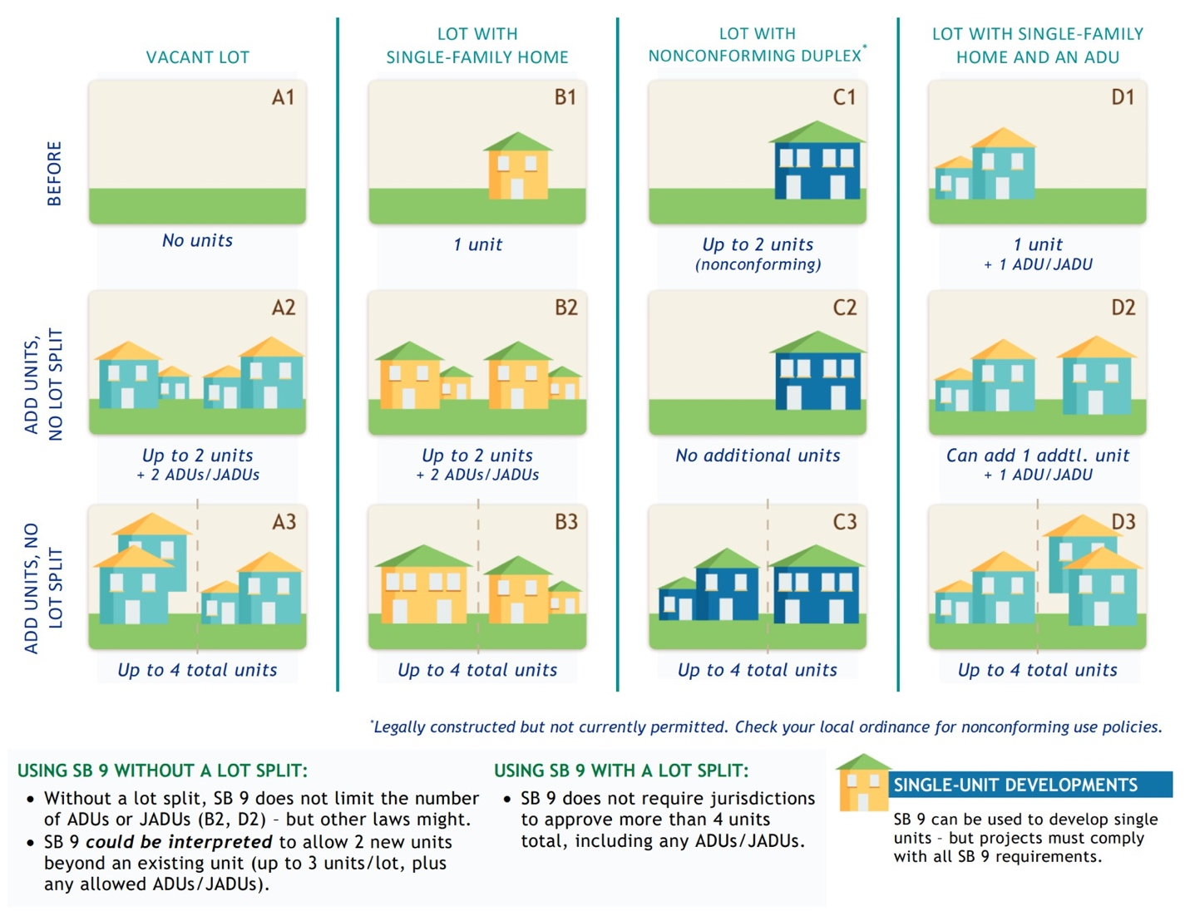
POTENTIAL NEW HOME CREATION

[Jurisdiction Name] has approximately [#] single-family residential lots, occupying [#] acres, that would be subject to SB 9. [Include additional details on the housing stock that would be affected].

It is unclear how many homes will be created by SB 9 over time. While SB 9 increases the zoned potential for residential units in single-family neighborhoods, market conditions and other factors are likely to limit the impacts of SB 9.

While SB9 applies to an estimated [#] parcels in [Jurisdiction Name], past experience with state housing laws such as Accessory Dwelling Unit laws suggest that only a small percentage of owners will choose to use SB9. For reference, in the last year, a similar number of parcels were eligible to build two ADUs (one full size and one junior) in [Jurisdiction Name], but only [#] permits for ADUs issued, and all/almost all of those were for one ADU per lot.

In July, UC Berkeley's Terner Center for Housing Innovation published a report on SB 9, concluding that single family homes would continue to be the dominant land use in areas covered by SB 9. This is because single family sales prices are high, many lots have limited buildable area, and construction costs limit what is feasible. Even when the economics are right, many property owners will still choose not to build.

[FOR JURISDICTIONS WITH MORE THAN 5,000 SINGLE-FAMILY PARCELS]
The report estimates that [#] more of [Jurisdiction Name]'s single-family parcels would be economically viable to allow new unit construction under SB 9, compared to current law. This represents the potential creation of [#] new homes. Note the Terner Center projection is a snapshot of economic viability under current market conditions, not a time-horizon forecast. Changes in land, labor, and material cost over time will continue to shift the number of parcels that may be potentially developed under SB 9.

REGIONAL HOUSING NEEDS ALLOCATION (RHNA)

SB 9 units may be able to count for purposes of Housing Elements and RHNA, but the exact methodology is currently unclear. In future years, it will be based on actual construction trends, but for the upcoming housing element, there is not time to establish a pattern. HCD is expected to come out with guidance on this in the coming months.

Jurisdictions must include all SB 9 units and applications for urban lot splits in their annual progress reports to the state.

MISSING MIDDLE HOUSING

“Missing middle housing” refers to small-scale multifamily housing that can range from duplexes to townhouses to smaller apartment buildings that are compatible with walkable neighborhoods. Missing middle housing has captured the interest of many jurisdictions that seek to increase housing density in a neighborhood-friendly way. Though zoning changes in the mid-1940s and later made duplexes, triplexes and quads illegal in most residential neighborhoods, many of these house-scaled multifamily buildings exist comfortably and unnoticed in many older communities throughout the Bay Area.

Some examples of duplexes are presented below:

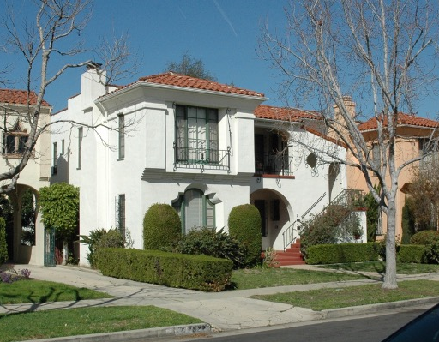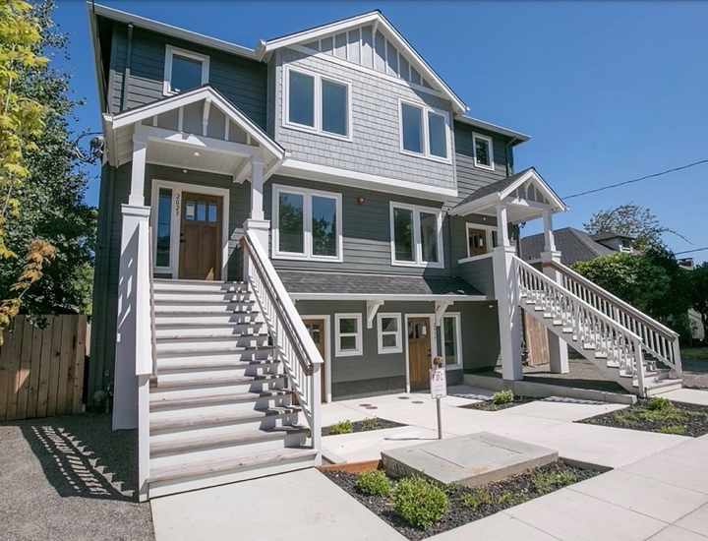

REGULATIONS

The law details which ways jurisdictions may regulate SB 9 proposals. There are some actions jurisdictions must take, some decisions jurisdictions can choose to take, and some topics they may not regulate.

The following requirements and limitations apply to all two-unit housing development and urban lot split projects under SB 9:
- Ministerial review - Jurisdictions must review and process applications for SB 9 two-unit housing developments and urban lot splits ministerially without any discretionary/subjective review or CEQA.
- Objective standards - Jurisdictions may only impose objective zoning, design, and subdivision standards. Any standards shall not physically preclude the construction of two units of less than 800 square feet each, per property.
- 4-foot rear and side setbacks - Jurisdictions may not impose residential setbacks greater than 4 feet for side and rear property lines.
- Rebuild demolished building with same setback - Jurisdictions may not impose any setback requirements for a new residence constructed in the same location and to the same dimensions as an existing structure that is demolished.
- Zero or one parking space - Jurisdictions may not require more than one parking space per unit. For properties within one-half mile walking distance of either a high-quality transit corridor or a major transit stop, or within one block of a car share vehicle, no parking spaces may be required.
- Denials for public health and safety exemption - Jurisdictions may only deny an SB 9 proposal if the Building Official finds that it would have a "specific, adverse impact [as defined by the law], upon public health and safety or the physical environment and for which there is no feasible method to satisfactorily mitigate or avoid the specific, adverse impact." Any denials must be based on objective, identified public health and safety standards, policies or conditions that existed when the application was submitted.
- Attached buildings allowed - Jurisdictions may not reject an application because it proposes adjacent or connected structures provided that the structures meet building code safety standards and are sufficient to allow separate conveyance. SB 9 does not define “sufficient to allow separate conveyance.”

The following additional limitations apply to all urban lot split projects under SB 9:
- Dedications/Improvements - Jurisdictions may not require dedications of rights-of-way or the construction of offsite improvements.
- Easements - Jurisdictions may require easements required for the provision of public services and facilities and may require that parcels have access to, provide access to, or adjoin the public right of way.
- No correction of non-conforming conditions- Jurisdictions may not require correction of an existing non-conforming condition as a condition for ministerial approval.

SB 9 includes a few additional rules, including jurisdictions’ ability to require percolation tests for onsite wastewater treatment in two-unit development projects and the lack of a public hearing requirement for coastal development permit applications. Projects located in coastal areas must still conform to their local coastal plan.

ADDITIONAL INFORMATION ON APPLICABILITY AND RESTRICTIONS

Applicability:
SB 9 applies in all Urban Areas, as defined by the US Census Bureau, except for the following:
- Environmental Sensitivity/Environmental Hazards - Properties designated as:
  - Prime farmland or farmland of statewide importance
  - Wetlands
  - Within a very high fire hazard severity zone (with exceptions)
  - A hazardous waste site (with exceptions)
  - Within a delineated earthquake fault zone (with exceptions)
  - Within a flood zone (with exceptions)
  - Identified for conservation or under conservation easement
  - Habitat for protected species
- Ellis Act Properties where the Ellis Act was used to evict tenants at any time in the last 15 years.
- Historic Properties - Properties located in a state or local historic district, or properties designated historic landmarks.

Other restrictions:
- Deed restricted affordable housing and rental housing – SB 9 projects may not demolish housing that is subject to a recorded covenant, ordinance, or law that restricts rents to levels affordable to persons and families of moderate, low, or very low income. Nor is it allowed for housing that is subject to any form of rent or price control through a public entity’s valid exercise of its police power. Demolition is also not permitted for housing that has been occupied by a tenant in the last three years.
- No short-term rentals – Rental terms less than 30 days are not allowed.
- Limits on demolition - Projects may not demolish more than 25 percent of existing exterior structural walls unless (a) the property has not been occupied by a tenant for 3 years or (b) otherwise allowed by the jurisdiction.

Urban Lot Split-Specific Rules:
- One use - Only one lot split allowed under SB 9, but note further splits may be possible under regular subdivision procedures.
- Residential only - The uses on the resulting lots are limited to residential uses.
- Approximately equal size - Each new parcel must be "approximately equal" in lot area provided that one parcel shall not be smaller than 40 percent the size of the original parcel
- Minimum 1,200 sf parcel - No parcel shall be less than 1,200 square feet. Jurisdictions may by ordinance adopt a smaller minimum lot size subject to ministerial approval.
- Intention to occupy - The subdivider must sign an affidavit stating they intend to occupy one of the units for a minimum of three years. The local jurisdiction cannot impose additional owner occupancy standards. Community land trusts and qualified nonprofits are exempted from this requirement.
- Limits on adjacent urban lot splits - Neither the subdivider nor any person "acting in concert" with the subdivider has previously subdivided an adjacent parcel using an urban lot split. SB 9 does not define what "acting in concert" means or how it would be proven.

KEY ACTIONS AND DECISIONS

SB 9 takes effect on January 1, 2022. In order to be prepared for potential SB 9 applications, [Jurisdiction Name] must make a few decisions and take some key actions as soon as possible.

PART 1: Staff seeks guidance on this key question: What does the council like about missing middle housing and what aspects do they have concerns about?

This input will help guide [Jurisdiction Name]’s approach to SB 9 implementation – the adoption of not only an SB 9 implementing ordinance but also any objective zoning/subdivision/design standards that are needed.

PART 2: Staff seeks guidance on the following policy implementation questions:

- Parking - Should parking be set to the state limits or lowered?
- Owner occupancy - Should there be owner occupancy requirements for 2-unit developments?
- ADUs – To the extent SB 9 permits [Jurisdiction Name] to decide, should we allow ADUs with SB 9 properties?
- Larger units – Does [Jurisdiction Name] want to encourage units larger than 800 sf?
- Lot split versus small multifamily on one lot – Does [Jurisdiction Name] prefer to incentivize owners to choose urban lots splits or 2+ units on a single lot, or do we have no preference?
- Objective standards – Should [Jurisdiction Name] apply regular objective standards to the extent they don’t preclude objective standards, or should we adopt a new set of objective standards?

Several additional decisions remain, but these are a few of the most important choices that [Jurisdiction Name] will make with respect to the successful implementation of future SB 9 projects.

NEXT STEPS

Based on the Council’s direction, potential next steps include:

- Implementing Ordinance
- Objective Zoning/Subdivision/Design Standards
- Application Forms and Checklist

UC Berkeley’s analysis is based on the July 2021 version of the bill, which was more permissive than the version enacted.
Resource: Terner Center's "Will Allowing Duplexes and Lot Splits on Parcels Zoned for Single-Family Create New Homes?"
Resource: Opticos Design's Missing Middle website

