ADU Homeowner Survey Information for Jurisdictions
This document describes how jurisdictions can use the ABAG ADU Homeowner Survey to track the affordability of new ADUs. It is particularly useful for those jurisdictions that made commitments in their Housing Element to monitor ADU affordability. Jurisdiction participation is completely optional.

Background
ABAG’s Regional Housing Technical Assistance Program has launched an online homeowner survey to help jurisdictions meet ADU monitoring requirements made in their Housing Elements. Specifically, the survey will allow jurisdictions to document and report on the affordability of new ADUs (e.g., low-income, moderate-income, etc.) The survey was developed in consultation with a jurisdiction advisory group and has been reviewed by HCD.
Participation is 100 percent optional. If interested, your jurisdiction can ask (or require) homeowners to fill out the survey as part of the ADU approval process. The survey can be found here: bit.ly/ADUHomeownerSurvey

Key Next Steps
- Decide if your city/county wants to participate
- Decide if your city/county wants the survey to be voluntary or mandatory
- If the survey is mandatory, decide how your city/county will integrate the survey into your ADU approval process
The following pages provide more information. Additional detail and sample flyers for distribution to homeowners are available via this link.
If interested in using the survey tool, share your contact information using this form. Contact Hannah Diaz, hdiaz@bayareametro.gov, for more information.
We welcome your feedback on this new initiative.

Process
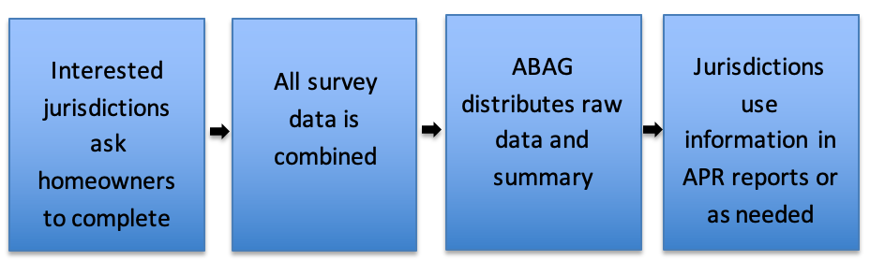

Frequently Asked Questions
Does my city/county need to participate? No. It is voluntary and meant as a service to cities that need to report on ADU affordability to HCD.
When do homeowners fill out the survey? Jurisdictions can decide when they want homeowners to complete the survey and if it is voluntary or mandatory. Cities may want to require evidence that the survey was completed with the building permit application or before issuing the Certificate of Occupancy.
Can my city/county see individual answers? ABAG will release a summary after three months, as well as the raw data, after removing homeowner email addresses.
Can my city/county start or stop participating at any time? Yes. Simply stop sharing the link with homeowners if you decide to stop participating, or start sharing the link if/when you decide to use this tool.

Additional Information
How the Survey Was Developed
The survey was developed with a city and county advisory group. It asks basic questions that enable local governments and ABAG to know the affordability of new ADUs. HCD has reviewed the survey, stating they believe it will meet a typical jurisdiction’s monitoring needs.
Data Collection Process
If interested, cities or counties can include the online homeowner survey as part of the ADU permitting and approval process in one of two ways. Some planning/building departments are interested in requiring homeowners to complete the survey before issuing a Building Permit or Certificate of Occupancy. Other jurisdictions will provide a link to the survey but not require it. Once homeowners complete the survey, they will receive an email confirmation, which can be used as proof of completion for cities and counties. All jurisdictions will use the same survey link with the same questions, allowing ABAG to report back to jurisdictions the data for their city/county as well as aggregated data for each county and the nine-county region.
Data Processing and Summary
RHTA staff will summarize and distribute the results quarterly for the first year, then annually. The survey includes city or county location as one of the questions, which allows data to be summarized for the region, county and by jurisdiction. If five or fewer responses are received for a jurisdiction, these responses will only be reported in the aggregate.
Paper Survey
In cities that require participation, the survey asks homeowners for an email address. To address privacy concerns, homeowners who do not want to provide an email address have the option of filling out a paper survey that does not ask this question. Jurisdiction staff are asked to enter the information from the paper survey into the online form. Jurisdiction staff should enter their own email address into the online form if entering information from a paper survey.

Survey Questions
- County
- City or Community
- What type of ADU are you building?
[Attached ADU (new construction); Detached ADU (new construction); Garage conversion; Interior conversion (renovation); Junior ADU]
- Select all the following design options that apply to your ADU:
[Custom design; Pre-approved design plans; Modular/prefabricated/manufactured]
- What has been the most difficult part of the ADU permit process?
[Understanding the design requirements; Understanding the permit requirements; Working with city staff; Working with the design team]
- Do you plan to initially use the ADU as housing?
[Yes, this unit will be used for housing; No, this will not be used for housing]
- Who do you expect to live in the ADU?
[Myself; Family; Friend; Someone else (will find a renter)]
- How many square feet will your ADU have? (estimates are ok)
- How many bedrooms will the ADU have?
[0, 1, 2, 3 or more]
- What do you expect the approximate monthly rent to be?
[$1 - $1000; $1001 – $1500; $1501 - $2000; $2001 - $2500; $2501 - $3000; More than $3000; Not planning to charge rent; Decline to state]
- Which utilities will the tenant pay for (in full or part)?
[Electricity; Gas; Water/sewer; Trash; Not sure at this time; No utilities]
- Are you in a city/town/county that requires you to fill out this survey?
- Homeowner Email
- Do you want to answer optional demographic questions?

Optional demographic questions
- What is the age of the head of your household?
[Under 45; 45-64; 65+; Decline to state]
- What is the race of the head of your household?
[Asian; Black/African American; Latino/Hispanic; White; Another race; Decline to state]
- If another race was selected above, please specify.
- What is the primary language spoken in your home?
[English; Spanish; Chinese; Another language; Decline to state]
- If another language was selected above, please specify.
- What is the number of people who live in your household?
[0, 1, 2, 3, 4, 5 or more, Decline to state]
- What is your household income?
[Under $75,000; $75,000-$99,999; $100,000-$149,000; $150,000-$199,999; $200,000 or more; Decline to state]

