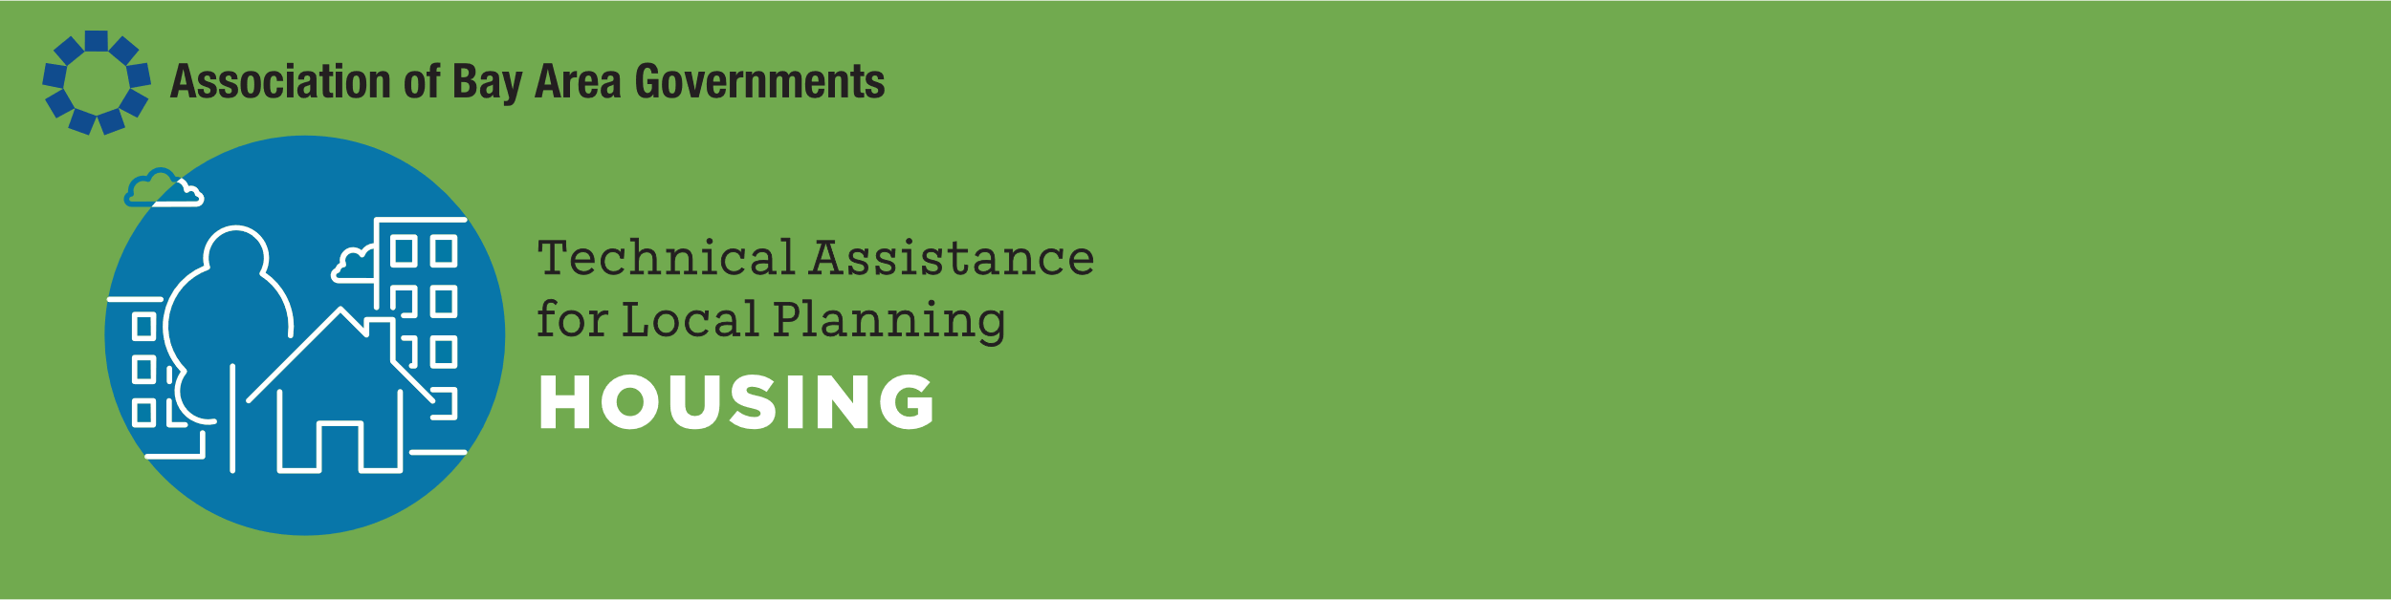
DISCLAIMER: This document is intended to provide general information and does not constitute legal advice. Additional facts, facts specific to a particular situation, or future developments may affect the subjects discussed in this FAQ. Seek the advice of your attorney before acting or relying upon the following information.

Timing Requirements for Adoption of the Housing Element and Required Rezoning
  - Technical Memo, Updated April 2023
AB 1398 (Chapter 358, Statutes of 2020) amended the provisions of state housing element law related to the implications of adopting a housing element after the due date. The current deadline for jurisdictions in the nine counties that are members of the Association of Bay Area Governments (ABAG) to adopt a housing element substantially in compliance with state law is January 31, 2023.

Previous Cycle Rules
To understand the new rules for adoption of a housing element, it may be helpful to compare them with those adopted in the last housing element cycle, the fifth cycle, when housing elements were due in January 2015. In the fifth cycle, if housing elements were not adopted by 120 days after the due date, the local jurisdiction was required to prepare a new housing element every four years, rather than every eight years. Those jurisdictions that adopted housing elements more than 120 days after the due date were required to adopt a mid-cycle housing element in 2019.

New Sixth Cycle Rules
AB 1398 has eliminated any requirement for a four-year housing element once the Department of Housing and Community Development (HCD) has found a community’s sixth cycle housing element in conformance with state law (Government Code Section 65588(e)(4)(A)). Instead, state law sets deadlines for housing element adoption and rezoning and consequences if those deadlines are not met.

Housing Element Adoption and Timeline to Rezone
- If a housing element is adopted and found by HCD to be in compliance with state law by May 31, 2023, then the jurisdiction has approximately three years after the date it adopts its housing element to complete all rezoning required to provide adequate sites (Section 65583(c)(1)(A)).
- If HCD does not find a housing element to be in compliance by May 31, 2023, then all rezoning required to provide adequate sites must be accomplished by January 31, 2024 (Section 65588(e)(4)(C)(i)).
  - Note that HCD has 60 days to review an adopted housing element (Section 65585(b)(3)). Any community desiring to have three years to adopt the necessary zoning should adopt a compliant housing element by April 1, 2023.
- If a housing element is adopted after January 31, 2024, HCD cannot find it in compliance with state law until all necessary rezoning is adopted (Section 65588(e)(4)(C)(iii)).
In the Southern California Association of Governments (SCAG) region, the due date for Housing Elements, October 15, 2021, has passed, and most jurisdictions are still working with HCD to receive certification.

Rezoning of Adequate Sites
If rezoning is not complete by the appropriate rezoning deadline as stated above, HCD is authorized to:
- Revoke its findings of compliance until rezoning is complete; and/or
- Refer the agency to the Attorney General (Section 65585(i), (j)).
HCD has adopted an additional policy relating to rezoning sites for lower income housing:
- If zoning required to provide adequate sites for lower income housing is adopted after the housing element due date of January 31, 2023, it must provide for “by right” approval.
  - “By right” approval means that a housing project that does not require a subdivision and that contains 20 percent lower income housing is exempt from the California Environmental Quality Act (CEQA). A jurisdiction may require design review based on objective standards, but only if its “by right” ordinance requires design review approval (Section 65583.2(i)).

Limitations on Denial of Certain Housing Projects
If January 31, 2023 passes without adoption of a sixth cycle housing element substantially complying with state law, this may have impacts on a jurisdiction’s ability to deny certain housing projects that do not comply with the community’s zoning and general plan. See discussion of the so-called “Builder’s Remedy” on ABAG’s website. Consult with your jurisdiction’s attorney regarding the impact of these provisions.

Eligibility for Certain Funding Programs
If a housing element is not in substantial compliance with state law or not found to be in compliance by HCD, the jurisdiction may not be eligible for certain funding programs.
Funding programs that may require the local jurisdiction’s adopted housing element to be in compliance with HCD at a key milestone include:
- Community Development Block Grant Program
- Infill Infrastructure Grant Program
- Transit Oriented Development Program
- Local Housing Trust Fund Program
- Affordable Housing and Sustainable Communities Program
- Permanent Local Housing Allocation Program
- Caltrans Sustainable Communities Grant Program
- MTC’s One Bay Area Grant (OBAG) Program
Funding programs that reward or incentivize projects in jurisdictions with compliant housing elements include:
- Local Partnership Program: Projects are evaluated on how they advance housing element goals.
- Transit and Intercity Rail Capital Program: Projects must document how transit ridership growth is supported by housing policies including evidence of compliance with state-required housing plans.
- Active Transportation Program: Infrastructure projects must address their potential to support existing and planned housing, and planning projects must be consistent with local housing policies.
- HOME Investment Partnerships Program: Applications receive points for housing element compliance.
- Solutions for Congested Corridors Program: Projects must address how they support infill development, which may include identifying housing element policies that streamline multifamily housing.

Some Housing Element Dates to Remember

January 31, 2023
- Deadline to have Housing Elements substantially in compliance with state law adopted by City Council or Board of Supervisors.
- Any rezonings that happen after this date, or need to happen after this date, must provide for "by right" approval of sites designated for lower income housing.

May 31, 2023 (120 days after the housing element adoption deadline)
- If HCD finds a housing element in compliance by May 31, 2023, the jurisdiction has approximately 3 years from the date of adoption to complete all rezoning.
- If a housing element is NOT found in compliance by May 31, 2023, all rezoning must be completed within one year of January 31. 2023.

January 31, 2024 (One year after the original adoption deadline)
- Rezoning deadline for jurisdictions that did not meet the May 31, 2023 compliance deadline.
- Starting January 31, 2024, HCD will not find any newly adopted housing elements in compliance with state law unless the required zoning is in place.

2026 (Three years after compliant housing element adoption)
- Rezoning deadline for jurisdictions that HCD finds in compliance by May 31, 2023.

Subsequent citations are to the Government Code unless otherwise stated.
The due date for these jurisdictions is either three years after the date the jurisdiction adopted its housing element, or three years after the date that is 90 days after the jurisdiction received HCD’s comments on its draft element, whichever is earlier.
ABAG Builder’s Remedy & Housing Elements: https://abag.ca.gov/technical-assistance/builders-remedy-housing-elements
Note there may be distinctions between “being in substantial compliance” and “determined by the Department to be in compliance.”
This list may not be exhaustive, and each of these programs has different requirements for eligibility. Please check the current regulations and guidelines for any funding program your jurisdiction is considering.
HCD’s interpretation is that a jurisdiction is only in compliance with Housing Element law after HCD issues a formal letter finding them in compliance. This letter comes after the jurisdiction submits an initial draft, considers HCD’s initial comments, and adopts the Housing Element.
If rezoning is not complete by the appropriate deadline, HCD is authorized to (1) revoke its findings of compliance until rezoning is complete and (2) refer the agency to the state attorney general.
If rezoning is not complete by the appropriate deadline, HCD is authorized to (1) revoke its findings of compliance until rezoning is complete and (2) refer the agency to the state attorney general.

