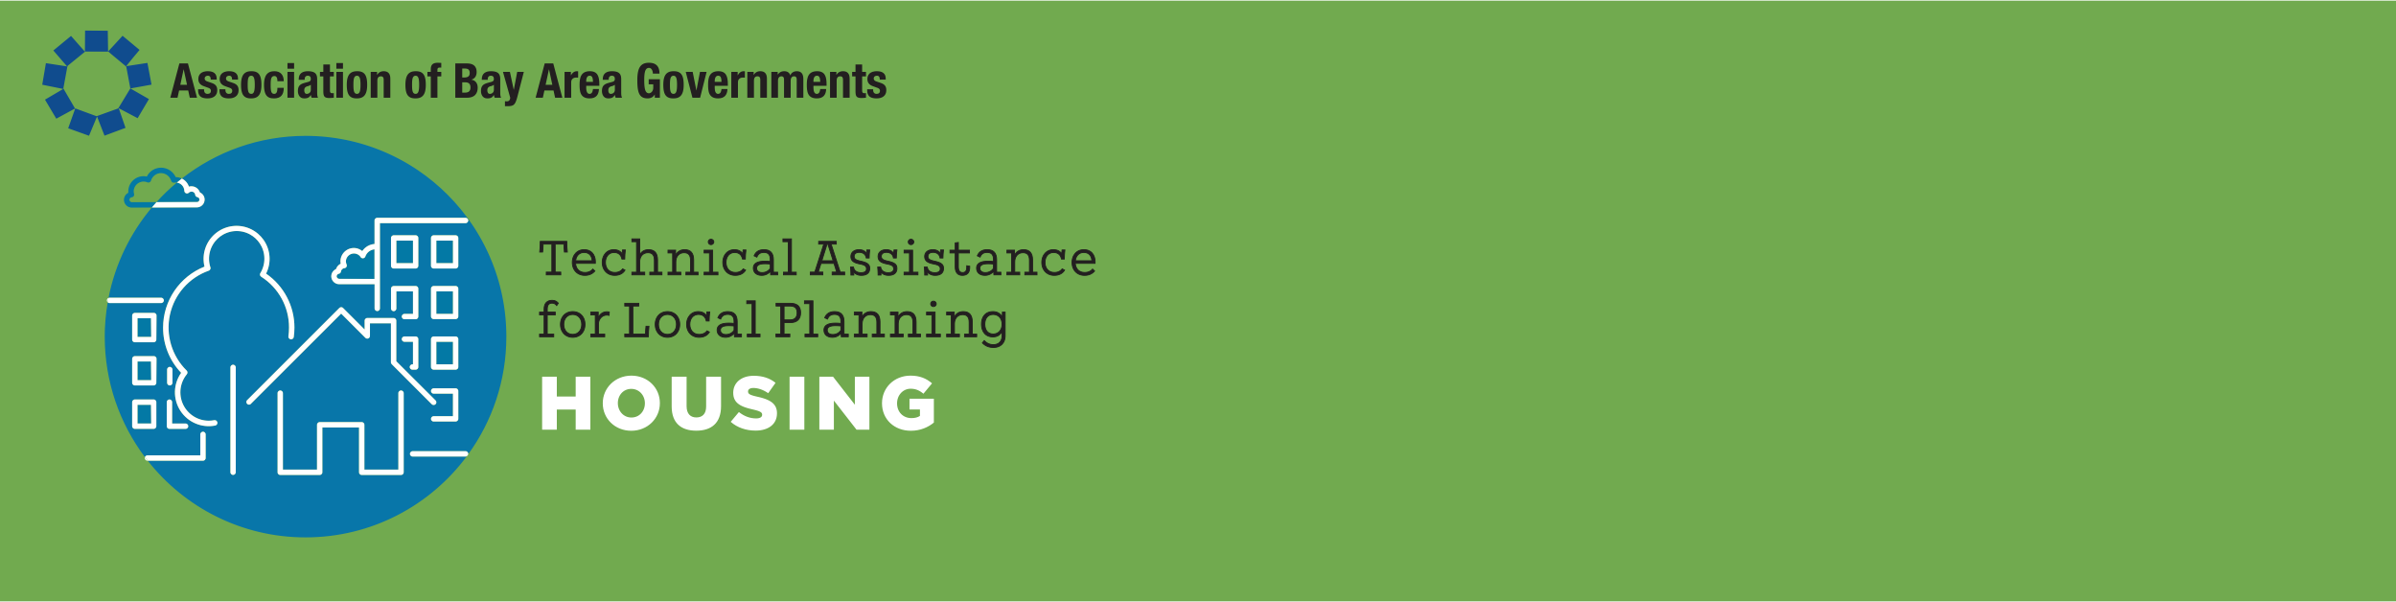

Consequences of Late Adoption of the Housing Element
  - Technical Memo, July 2022

Requirements for Adoption of the Housing Element and Required Rezoning
AB 1398 (Chapter 358, Statutes of 2020) amended the provisions of state housing element law related to consequences of adopting a housing element after the due date. The current deadline for jurisdictions in the nine counties that are members of the Association of Bay Area Governments (ABAG) is January 31, 2023.

Previous Cycle Rules
To understand the new rules for adoption of a housing element, it may be helpful to compare them with those adopted in the last housing element cycle, the fifth cycle, when housing elements were due in January 2015. In the fifth cycle, if housing elements were not adopted by 120 days after the due date, the local jurisdiction was then required to prepare a new housing element every four years, rather than every eight years. Those jurisdictions that adopted housing elements more than 120 days after the due date were required to adopt a mid-cycle housing element in 2019.
Cities and counties tended to view the 120-day period as a “safe harbor” that allowed housing elements to be adopted within that period without consequences.

New Sixth Cycle Rules
AB 1398 has eliminated any requirement for a four-year housing element once the Department of Housing and Community Development (HCD) has found a community’s sixth cycle housing element in conformance with state law (Government Code Section 65588(e)(4)(A)).
Instead, there are two formal consequences for failing to adopt and receive HCD certification of a housing element within 120 days of the deadline:
- If a housing element is not adopted and found by HCD to be in conformance with state law within 120 days of the due date, then all rezoning required to provide adequate sites must be accomplished within one year of the due date (by January 31, 2024 for Bay Area jurisdictions), rather than within three years plus 120 days of the due date (Section 65588(e)(4)(C)(i)).
  - HCD has 60 days to review an adopted housing element (Section 65585(b)(3)). Any community desiring to have three years to adopt the necessary zoning must adopt a compliant housing element within 60 days of the due date, or by April 1, 2023.
- If a housing element is adopted more than one year from the due date, HCD will not find it in compliance with state law until all necessary rezoning is adopted (Section 65588(e)(4)(C)(iii)).
HCD has also adopted a policy relating to completing rezoning by the due date for the housing element:
- If zoning required to provide adequate sites for lower income housing is adopted after the housing element due date of January 31, 2023, it must provide for “by right” approval.
  - “By right” approval means that a housing project that does not require a subdivision (a rental project) and that contains 20 percent lower income housing is exempt from the California Environmental Quality Act (CEQA). Only design review based on objective standards may be required, but the local ordinance must provide for this (Section 65583.2(i)).
In the Southern California Association of Governments (SCAG) region, the due date for Housing Elements, October 15, 2021, has passed, and most jurisdictions are still working with HCD to receive certification.

Limitations on Denial of Certain Housing Projects
Once the due date passes without adoption of a housing element, the content of the housing element may no longer comply with state law.
Under The Housing Accountability Act housing projects where 20 percent of the total units are affordable to lower income households may only be denied under limited circumstances that include inadequate water and sewer, a “specific health or safety impact,” lack of compliance with state or federal law, and agricultural or natural resource zoning (Section 65589.5(d)). Such a project can also usually be denied if it is inconsistent with both the land use element and zoning ordinance, but it cannot be denied for those reasons if the Housing Element is inconsistent with state law or if the housing development project is proposed on a site shown to be suitable for affordable housing in the Housing Element and consistent with the density in the Housing Element, even if the rezoning has not yet been completed (Section 65589.5(d)(5)).
Similarly, if rezoning has not been completed on time, a housing development project containing 49 percent affordable units that is proposed on a site proposed to be rezoned must be reviewed “by right” and approved unless the community can find that the project would result in a “specific adverse impact” that cannot be mitigated (Section 65583(g)).
It is also important to remember that under the Housing Accountability Act, so long as a proposed housing development project is consistent with the objective general plan standards and criteria, but not consistent with the zoning, the proposed housing development project is considered consistent with the applicable zoning standards and a rezoning is not required (Section 65589.5(j)(4)). Consequently, once a housing element has been adopted specifying the allowed density of a site, in some cases a housing development project consistent with that density may be able to proceed without a rezoning.

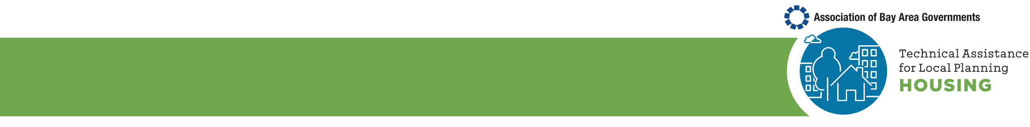
Appendix - Funding Tied to Housing Elements
State funding programs that incentivize greater coordination with housing planning, include:
- Local Partnership Program: Projects are evaluated on how they advance housing element goals.
- Transit and Intercity Rail Capital Program: Projects must document how transit ridership growth is supported by housing policies including evidence of compliance with state-required housing plans.
- Active Transportation Program: Infrastructure projects must address their potential to support existing and planned housing, and planning projects must be consistent with local housing policies.
- HOME Investment Partnerships Program: Applications receive points for housing element compliance.
- Solutions for Congested Corridors Program: Projects must address how they support infill development, which may include identifying housing element policies that streamline multifamily housing development.
Funding programs that require a local jurisdiction’s housing element compliance include:
- Community Development Block Grant Program
- Infill Infrastructure Grant Program
- Local Housing Trust Fund Program
- Affordable Housing and Sustainable Communities Program
- Permanent Local Housing Allocation Program
- Caltrans Sustainable Communities Grant Program

Subsequent citations are to the Government Code unless otherwise stated.

