RESOURCE
Resilient Housing Policies & Programs
Example policies and programs for general plan housing elements
Version 1 – July 2021

CONTENTS (41 pages)

Introduction to the Resilient Housing Policy Resource (page 2)

How-to-Guide for the Resilient Housing Policies (page 3)

Equity Considerations for Resilient Policies (page 4-5)

Resilient Housing Policies (pages 4-28)

Annotated Bibliography – Original Sources for the Policies (pages 37-38)

Introduction to the Resilient Housing Policy Resource
Jurisdictions across the state are required to identify sufficient housing sites pursuant to the Regional Housing Needs Assessment (RHNA) in their Housing Element Updates. In addition, there are requirements, such as the Affirmatively Furthering Fair Housing (AFFH), which cities must also meet to have a compliant Housing Element, regardless of hazards in their community. However, the Housing Element can also be a pathway to not only integrate resilience and ensure that existing and to be constructed housing will last into the future, but also align other planning efforts, such as Local Hazard Mitigation Plan’s, safety elements, or environmental justice efforts. No matter a jurisdictions level of capacity, using the Resilient Housing Policy Resource, all cities can incorporate some level of resilience into their Housing Elements by directly incorporating either short term easy to implement policies, and/or long-term policies that set the stage for harder to reach adaptation goals. Jurisdictions will need to balance the tradeoffs between equity, housing, and environmental goals while zoning for future housing and placing housing in areas where they may be at risk to hazards. Resilient housing is a key piece to fostering resilient communities and can work to reduce a community’s housing risk to climate change and seismic hazards (i.e. wildfire, flooding, sea level rise, extreme heat, drought, seismic, and multi-hazards).
A community’s risk refers to the degree to which natural, built, and human systems have the potential to be damaged or lost as a result of a hazardous condition from exposure to climate change and seismic threats. As depicted in Figure 1 below, risk reduction can be achieved by reducing the exposure, sensitivity and/or consequences of hazards and by increasing a jurisdictions adaptive capacity to prepare and respond to them. Risk can increase or decrease because of decisions and policies around physical (built and environmental), social, political, and/or economic factor(s). (APG, OPR, 2020).
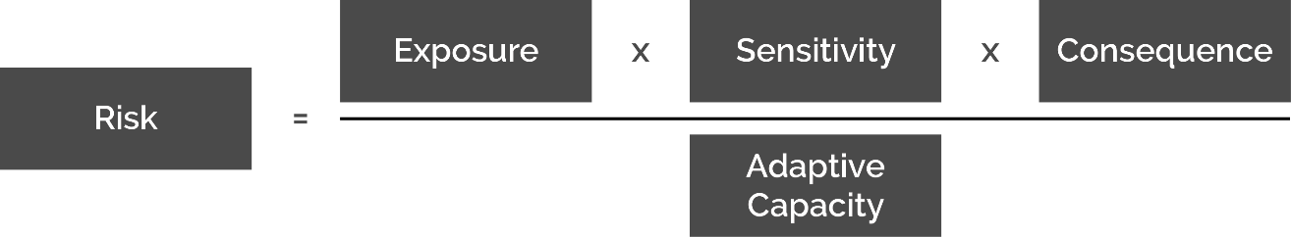
Figure 1. Components of Risk
The policies within the Resilient Housing Policy Briefer were developed to help address a community’s existing and future housing stock’s exposure, sensitivity, consequences, and adaptive capacity to hazards. Figure 2 illustrates the policy organization into the four components described above as well as the secondary organizing themes for the 60 policies in the document.

Figure 2. Resilient Policy Universe Organizing by Components of Risk

How-to-Guide for the Resilient Housing Policies
This policy resource is intended to be a starting point for housing policy development as jurisdictions update their Housing Elements and make policy decisions. There is not one way to address your community’s risk to hazards, however the policies presented here provide a unique opportunity to integrate resilience directly into the Housing Element as one avenue, among many, to increase your community’s ability to prepare, respond, and recovery from a destabilizing event. These policies have been adapted from their original language and combined with similar resilient policies inventoried. The policies were developed with the intention to be broad enough to apply to any hazard. Therefore, each policy should be refined to best address a jurisdictions unique vulnerabilities, and the needs of the community. For more context on the policies or find original policy language, consider exploring source documents in the Annotated Bibliography (page 38) and the full Resilient Housing Excel Policy Universe.
The Resilient Housing Policy Resource should be thought of as a menu of possibilities from which to consider a few policies and programs to include, or at the very least have discussions around tradeoffs when considering housing, resilience, and equity decision making. Before diving into this resource, it is important to note that all policies and programs vary in cost, implementation, timeline, and level of community input needed. In the figure below, the policy title is an indicator for whether the measure is considered a policy or program (i.e. Avoid-1 is a policy, while Avoid-1.a is an implementing program). It is not intended for jurisdictions to incorporate every policy or program in this document or need to incorporate every program with a policy and vice versa. See Figure 3 for a description of how the policies are formatted in the document.

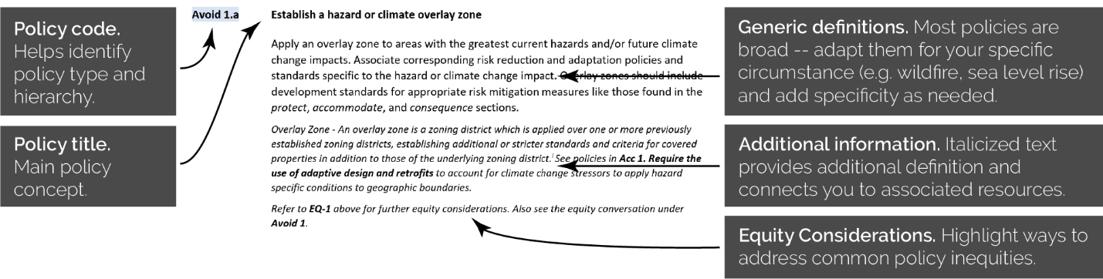
Figure 3. How to Read the Resilient Housing Policies and Programs

Equity considerations for resilient policies
Implementation of certain policies in isolation without companion policies can lead to exclusionary outcomes and unequal distribution of resources and have negative impacts on communities’ of color, lower income households, and residents with disabilities. Equity is defined as just and fair inclusion into a society in which all can participate, prosper, and reach their full potential. Planning and policy decisions should be made with those most affected in mind by encouraging active engagement within this communities to minimize impacts and make policies and programs more equitable. The USDN’s Guide to Equitable Driven Climate Preparedness includes a framework that provides a structure for understanding equity and the basis for how government institutions can improve equitable outcomes through their decision-making processes. The following equity considerations, derived from the USDN resource, are crucial for jurisdictions to explore to ensure that the outcomes of resilient policy implementation are fair and that the root causes of inequities are addressed through improved government processes and decisions. See Chapter 4 Equitable Climate Resilience Planning Solutions of the USDN guide for additional equity policy considerations in addition to the State of California’s Department of Housing and Community Development’s (HCD) Guidance to Affirmatively Furthering Fair Housing to consider how your resilience planning can be part of advancing Affirmatively Furthering Fair Housing in your Housing Element.
EQ-1. Ensure ample opportunity to place enough affordable housing outside of hazardous areas. Limiting or prohibiting new development in hazardous areas may reduce the availability of new housing. Hazardous area, for example flood prone areas, usually correlate with the locations of lower-income communities and communities of color, who are at high risk of displacement should a hazard occur. Limiting or prohibiting new development in these areas may reduce the availability of affordable housing. Ensure that affordable housing development projects are encouraged in areas at low risk of climate change hazards and require cost-reasonable mitigations for development in proposed areas of high-risk development, see EQ-3.
EQ-2. Rebalance the distribution of resources, benefits, and burdens regarding climate change and seismic challenges when implementing policies and programs. Prioritize resources for communities that experience the greatest inequities, disproportionate impacts, and have the greatest unmet needs. This may include evaluating how resources are currently being distributed and developing incentives and funding mechanisms, such as subsidies or rebates to implement installation of equipment, infrastructure, adaptation retrofits, ect., aimed at the most vulnerable populations or residents living in the most hazardous areas and making choices to focus on the areas in most need.
EQ-3 Maintain housing affordability and housing security with climate change adaptation regulations. Consider the costs of mandates and increased standards for climate change adaptation regulations and those standards and regulations on housing affordability. These standards and regulations may include building hardening, building materials standards, landscaping, and siting. Policies should balance the need for climate adaptation with the negative impact of increasing housing costs for vulnerable populations. The jurisdiction should provide incentives such as: reduced or waived fees, density bonuses, or more inclusive zoning requirements to offset increased costs of climate change adaptation regulations. When measures result in higher costs EQ-2 actions should be implemented to ensure lower-income homeowners are protected from being priced out of their property and lower-income renters have sufficient tenant protections to avoid eviction.
EQ-4. Create and implement planning processes that are transparent, fair, and inclusive when developing and implementing any program, plan, or policy. This may likely involve establishing new community outreach processes other than the standard planning process outreach. Community involvement, partnerships, co-design of plans and polices, and making space for communities to lead the decision-making process are critical components of equitable resilience planning. When done well, it ensures that issues of greatest concern for these communities who are disproportionately impacted by climate change are elevated throughout the process, analysis reflects community expertise and experiences, and adopted preparedness and adaptation policies prioritize frontline communities.
EQ-5. Research options for the use of tenant landlord agreements to encourage and support retrofits to rental housing units. Given that renters typically do not have control over building decisions, initial installation of equipment and infrastructure or adaptation retrofits can be expensive and cost prohibitive for many lower-income residents living in rental units. Traditional rental agreements, or leases, neither the landlord nor the tenant are incentivized to invest in efficiency or adaptation improvements that can lead to high-performance properties and/or reduced risk that benefits both entities. However, the burden should not fall on tenants, but landlords should be responsible for providing habitable, safe housing. Green leases, also known as energy-aligned leases, help to break down barriers. Green leases are leases which contain sustainability or environmental provisions as part of a landlord-tenant agreement. Consider researching options to incorporate green leases or provisions within tenant - landlord agreement, for residents and property owners for rental units so that all parties can equitably share in the costs and benefits of retrofit or efficiency programs. See more information on green leasing and green lease language examples here.
EQ-6. Empower the local work force by supporting living wages and benefits in your community. Actions could include expanding job training of lower-income residents in jobs generated by home installation, retrofit, or home weatherization programs. Consider partnering with community organizations to provide job training programs.

Table of Contents (text hyperlinks to the page)
Policies & Programs that Increase Adaptive Capacity (5 policies, 10 programs)
Adptv Cpty 1. Ensure consistency across multiple plans and synchronize local plans
- Dedicate a staff position or working group to facilitate planning and implementation of resilience measures (Adptv Cpty 1.a)
Adptv Cpty 2. Ensure adaptation planning includes best available science, adequate mapping, and consideration of planning horizons
- Identify spatial distribution of vulnerable populations (Adptv Cpty 2.a)
- Develop or enhance a community capacity inventory (Adptv Cpty 2.b)
- Coordinate standards for each hazard (Adptv Cpty 2.c)
Adptv Cpty 3. Develop an inclusive public engagement and education strategy
- Partner with community based organizations to disseminate best available hazard and climate change risk information (Adptv Cpty 3.a)
- Encourage and promote neighborhood-based communication networks (Adptv Cpty 3.b)
Adptv Cpty 4. Educate the community on actions they can take to reduce risk
- Publish maps for the community or link to others that do (Adptv Cpty 4.a)
- Encourage the use of interpretive signage on climate change impacts (Adptv Cpty 4.b)
- Launch an education outreach campaign (Adptv Cpty 4.c)
- Develop a comprehensive resilient home educational guidance checklist (Adptv Cpty 4.d)

Policies & Programs that Reduce Exposure (5 policies, 10 programs)
Avoid 1. Reduce or prohibit new development in the most hazardous areas
- Establish a hazard or climate overlay zone (Avoid 1.a)
- Utilize land use planning tools to site development away from hazards (Avoid 1.b)
- Develop adequate setbacks or buffers for new development (Avoid 1.c)
- Establish a transfer of development rights program (Avoid-1.d)
- Area of influence hazard evaluation (Avoid 1.e)
Avoid 2. Adaptive resettlement program or policy of strategic realignment
- Develop a plan for removal or relocation when planning new development that may be threatened in the future (Avoid 2.a)
- Identify triggers or conditions for relocation or removal of structures (Avoid 2.b)
- Develop incentives to relocate or acquire existing at risk development (Avoid 2.c)
Avoid 3. Use agriculture, and open space zoning to buffer development from hazards
- Reduce barriers to encourage Williamson Act use in high hazard areas (Avoid 3.a)
Protect 1. Site and design protective measures to reduce the extent of hazard and climate impacts
- Assess and monitor protective infrastructure (Protect 1.a)
Protect 2. Encourage forest and upper-watershed management activities that reduce the spread and intensity of wildfire and/or reduce the intensity of downstream flooding
Policies & Programs that Reduce Sensitivity (6 policies, 8 programs)
Acc 1. Require flood-proof construction methods, techniques, and mitigation
- Revise minimum building elevation standard to limit basements and first floor habitable space (Acc. 1.a)
- Require low-Impact stormwater best practice and development design (Acc. 1.b)
- When possible, use green infrastructure as a preferred alternative (Acc. 1.c)
Acc 2. Apply existing requirements to areas with high future risk
- Designate new and existing properties as fire compliant (Acc. 2.a)
Acc 3. Expand the use of drought tolerant requirements
- Expand efficient irrigation systems and climate adapted landscaping requirements (Acc. 3.a)
Acc 4. Expand extreme heat adaptation requirements
- Decrease risk from extreme heat impacts to residents through shaded canopy (Acc. 4.a)
- Require efficient air conditioning or cooling alternatives (Acc. 4.b)
Acc 5. Expand seismic retrofit requirements
- Amend local building code to better address seismic risks in new construction (Acc. 5.a)
Acc 6. Require 21st century home energy building materials, construction methods, and energy systems
Policies & Programs that Reduce Consequences (5 policies, 12 programs)
Life/Safety 1. Ensure evacuation routes and plans consider future populations and future hazard conditions
Life/Safety 2. Require measures to reduce the consequences of utility outages
- Encourage the adoption of battery systems or inverters for solar installations (Life/Safety 2.a)
- Encourage higher building envelope design for improved livability during outages (Life/Safety 2.b)
- Encourage local utilities to retain lifeline programs (Life/Safety 2.c)
- Encourage air filtration and building envelope improvements to improve indoor air quality during wildfire smoke events (Life/Safety 2.d; pg x)
Property 1. Establish a pre-disaster rebuild and recovery plan to assist the recovery following a hazard event
- Ensure rebuild plans maintain housing affordability (Property 1.a)
- Establish whether rebuilding is conditional, limited, or prohibited in different locations (Property 1.b)
- Have program structures in place to expedite debris removal and expedite reconstruction (Property 1.c)
- Plan for temporary housing in the post-disaster period (Property 1.d)
- Develop and implement a shelter-in-place program (Property 1.e)
- Establish an organizational structure for higher volumes of housing permits (Property 1.f)
Property 2. Promote long-term and more expansive insurance coverage
- Require contingency funds for new development in hazardous locations (Property 2.a)
Property 3. Create a fragile housing inventory
- Real estate and renter disclosure of hazards (Property 3.a)

Policies that Increase Adaptive Capacity
Adaptive Capacity is defined as the ability of a community to adjust to potential damage, to take advantage of opportunities, or to respond to consequences. (APG 2020) Ensuring a jurisdiction has sufficient adaptive capacity, is a crucial step for successful adaptation response now and in the future as the threat of hazards intensify and become more frequent. Jurisdictions can include policies that increase adaptive capacity now, so that tools, resources, and systems are put in place and can be relied upon as a resource down the road. Adaptive capacity increases both local governments and resident’s ability to better prepare, respond to, and recover from challenges in the future. These policies are organized into three categories: government process, utilizing complete and updated data, and community education and engagement. Building capacity in these areas is an important step to chart a resilient course and ensure the community has all the necessary tools, resources, and systems in place to successfully implement climate adaptation and hazard mitigation policies and projects.

Adptv Cpty 1. Ensure consistency across multiple plans and synchronize local plans
Align and coordinate updates to the community's General Plan Adaptation plan(s), and Local Hazard Mitigation Plan to efficiently meet requirements and SB 379. Synchronize future updates of the Safety and Housing Element to ensure compliance with Senate Bill 1035 and consistency between policies, strategies, and implementation measures. When appropriate, consider adoption of a multi-jurisdictional climate adaptation, climate action plans, sub-area plans, capital improvements plans, transportation plans, or Local Hazard Mitigation plan(s) that can address cross jurisdictional issues or issues in which coordination and pooling of resources is a benefit.
Refer to MTC/ABAG Briefer #1, Concurrent General Plan Element Update Considerations, which gives an overview on local planning alignment, review of resilience planning legislation, current state and regional resources, and considerations for local governments to integrate concurrent general plan element updates. HCD also has a resource discussing local planning requirements and integration as they relate to the Housing Element.
Refer to EQ-4 above for further equity considerations.
Adptv Cpty 1.a Dedicate a staff position or working group to facilitate planning and implementation of resilience measures
Designate a department, inter-agency working group, or staff position, with responsibility for monitoring, reporting and progress towards implementation of a climate action and adaptation strategy. Provide regular updates on progress and challenges to committees and/or council.
An existing staff position or a new role in the community’s government structure could be given the Chief Resiliency Officer title, responsible for coordinating relevant plans and/or implementation across multiple departments and external agencies.
Refer to EQ-4 above for further equity considerations.
Adptv Cpty 2. Ensure adaptation planning includes best available science, adequate mapping, and consideration of planning horizons
Ensure the best available, up-to-date scientific information about hazards shall be used in vulnerability assessments, permit applications that present hazard risks, and the preparation of technical reports and related findings. Map areas subject to existing and future hazards that present risks to life and property using multiple scenarios, including worst case scenario. When possible, identify planning time horizons for future hazards to evaluate development and community decisions against.
Climate-related risks are actively being studied and mapped. Integrating the “best available science,” may require frequent update, a change from the past where hazard maps remained relatively static over decades. Consider partnering with scientific institutions and/or universities to explore, access, and build capacity for best available science and tools.
Adptv Cpty 2.a Identify spatial distribution of vulnerable populations
Develop and update local community maps that identify vulnerable populations. Identifying vulnerable populations will align jurisdictions to comply with multiple state laws. Ensure the spatial distribution of these vulnerable populations is a considered metric and indicator in planning and policy development related to climate change and climate adaptation.
OPR’s resource, Identifying Vulnerable Communities, can help to identify communities that are both vulnerable to climate impacts (consistent with SB 379 requirements, Government Code Section 65302(g)), as well as identifying Environmental Justice communities (as required by SB 1000, Government Code Section 65302(h)). Because local jurisdictions are faced with implementing multiple, often overlapping planning requirements, this resource guide identifies areas where existing resources and tools can be used to meet multiple requirements.
Refer to EQ-4 above for further equity considerations.
Adptv Cpty 2.b Develop or enhance a community capacity inventory
Define the elements of a community capacity inventory (such as critical facilities and community services), engage city departments, Community Based Organizations, and other NGOs to build off existing information, and develop sustainable standards managing data.
Partnerships with NGOs such as Code for America could yield an open-source, collaborative format for collecting and sharing this information.
Adptv Cpty 2.c Coordinate standards for each hazard
Align or coordinate local efforts with state, regional, or county data and mapping standards for each climate change impact and seismic hazard when available. Ensure that city analysis, planning, and implementation use common datasets and standards when available so that individual jurisdiction do not need to recreate their own and this information is consistent.
Many climate change and seismic impacts have multiple mapped data sets from various government, academic, and non-profit organizations which can lead to issues when moving from policy analysis to planning to implementation.
The California Ocean Protection Council publishes guidance on sea level rise planning. The OPC suggests that the California shoreline be resilient to 3.5 feet of rise by 2050 and provides other guidance on risk aversion and planning in their Sea Level Rise Guidance to plan for at least 3.5’ of sea level rise.

Adptv Cpty 3. Develop an inclusive public engagement and education strategy
As climate change and its associated hazards have a disproportionate impact on vulnerable populations, the community shall develop a public outreach and engagement strategy that utilizes methods to engage the entire community and includes education components in all planning and policy-making processes for climate change and adaptation. Consider best practices for inclusive engagement including: holding varying meeting times to accommodate different schedules, holding meetings in locations accessible to those without transportation, providing culturally relevant language, providing childcare, diversifying outreach through storytelling and active listening techniques, and ensure all materials are developed and provided in multiple commonly spoken languages and designed to communicate effectively to all groups.
Refer to EQ-4 above for further equity considerations.
Adptv Cpty 3.a Partner with community based organizations to disseminate best available hazard and climate change risk information
Seek opportunities to fund and partner with existing, successful community-based programs (e.g. community health programs, neighborhood associations and advocacy organizations, volunteer groups, and others) to connect community members to hazard and climate change risk information. An example of such an expansion would be the promotion of voluntary retrofits to building owners in coordination with the public health sector Healthy Homes educational campaigns.
Refer to EQ-4 above for further equity considerations.
Adptv Cpty 3.b Encourage and promote neighborhood-based communication networks
Promote neighborhood-based communication networks through which community members can post requests for assistance, availability of tools/supplies, local ‘news’ updates, helpful resources, ect.
Research has shown that communities with stronger social networks have better outcomes after disruptive disaster events. Neighborhoods with existing communication channels may be more equipped, connected, and coordinated to respond and recover from an event.
To help neighbors connect, the City of Berkeley invites neighborhoods to co-host block party with the Office of Emergency Services and Public Works. To help incentivize the effort the program offers to bring free dumpsters for residents to fill.
Refer to EQ-4 above for further equity considerations.

Adptv Cpty 4. Educate the community on actions they can take to reduce risk
Develop and prioritize education on climate change impacts and risks through programs, partnerships, and guidance on the various climate hazards the jurisdiction is facing.
Refer to EQ-2 and EQ-4 above for further equity considerations.
Adptv Cpty 4.a Publish maps for the community or link to others that do
Review and publish for public the latest and most up to date climate change impact projections and hazard information from regional, state and federal agencies. Ensure all materials are clear and easy to understand and provided in multiple commonly spoken languages and that staff or additional information is available to help the community interpret maps if needed.
For current data, maps, and information on existing natural hazard potential and impact severity in the Bay Area, explore and utilize the MTC/ABAG Hazard Viewer Map, a tool developed and maintained by MTC/ABAG that includes a number of climate change and seismic hazard layers for jurisdictions to explore and download.
For current data, maps, and information on future climate conditions and projections across California, explore and utilize Cal-Adapt, a widely utilized tool for climate adaptation planning in the state. Cal-Adapt features a number of planning and data analysis tools covering various climate change hazards and is maintained by UC Berkeley and funding by the California Energy Commission and the Strategic Growth Council. Data and maps can be directly downloaded by all users. The Local Climate Snapshot tool is a starting place if you are looking to get a quick sense of climate impacts in your region. The Snapshot tool provides climate projections for temperature, precipitation, and wildfire. Additional variables e.g. sea level rise will be added when they become available. The Snapshot Tool was designed to be straightforward and accessible for all users. The linked website includes a short video on how to use the tool
For current data, maps, and information on sea level rise and flooding specific to the Bay Area region, explore ART’s Adapting to Rising Tides map explorer. The Flood Explorer helps jurisdictions learn about, explore and download flood maps to understand what could be at risk without future planning and adaption. While there are several sea level rise mapping tools available for San Francisco Bay and Delta, including the Cal-Adapt tool mentioned above, the ART maps in both the Bay and Delta are unique due to their fine scale resolution, stakeholder review process, overtopping analysis, and combination of storm and SLR flooding.
Adptv Cpty 4.b Encourage the use of interpretive signage on climate change impacts
Incorporate links and references in system maps and incorporate interpretive signage at multi-use path trailheads providing education on climate change related health threats including heat related illnesses, flooding risks, and wildfire smoke.
Adptv Cpty 4.c Launch an education outreach campaign
Work with community partners, local officials, and non-profit organizations to incorporate social media, traditional forms of outreach, and education programs into community plans that seek to educate homeowners and landlords on how to reduce risks to structures, landscaping, and property.
Adptv Cpty 4.d Develop a comprehensive resilient home educational guidance checklist
Consider developing a comprehensive guidance checklist for renters and building owners. The checklist, which could include permit applications for owners, should serve to provide education on activities that can improve a home and/or resident’s resiliency to existing and potential future climate change hazards. Consider developing a technical assistance program, incentives, or streamlining benefits to be made available to implement this policy.
In Marin County, the Green and Healthy Home Initiatives helps residents with upgrades that improves habitability, energy efficiency, waste reduction, and accessibility and safety
In Sonoma County, the County has bundled financing for wildfire safety and seismic improvements and a group of organizations have combined to offer streamlined energy rebates to help homeowners rebuild in an energy forward manner.
Refer to EQ-3 above for further equity considerations.

Policies to Reduce Exposure
Exposure is the presence of people, infrastructure, and other community assets located in areas that are subject to harm (APG, OPR, 2020). A straightforward way to decrease residential risk is to reduce the exposure of housing to the climate change or seismic hazard.
Avoid policies restrict or prevent development from occurring in areas with known hazards. Avoidance policies can be used when considering where to site future housing or how to manage rebuilding decisions when recovering from a damaging event. This approach can be difficult when other pressures lead to the consideration of growing in areas with risk. Further, there are potentially unequitable outcomes that could result from limiting or prohibiting new development in these areas which could exclude residents and reduce the availability of sites for affordable housing. Therefore, if including an avoidance policy to restrict housing in areas with hazard it is critical to also include companion land use policy that ensures ample amounts of affordable housing development projects are pursued in areas at low risk of climate change hazards.
As an alternative to avoiding the geographic area of a hazard, protect policies reduce exposure by implementing physical protections to reduce the frequency or intensity of hazards. Protect policies and structures can be further divided into “hard” and “soft” defensive measures or armoring.
Policies that reduce exposure are best considered at the early stages of the Housing Element process because it is the most straightforward and economically feasible to use land use decisions to not site and construct housing in areas where they will be exposed to hazards. The Housing Exposure Data Tables and the Housing Element Site Selection Tool (HESS) can be used to reveal what climate change and seismic hazards are present in the community. Data and maps can be a powerful tool allowing decision makers, staff, and the community to see the most at-risk locations in their community and help zero in on a narrower area of greatest risk.

DISCLAIMER ON AVOIDANCE STRATEGIES
The use of avoidance strategies should be done in measured ways and must consider requirements to identify sufficient housing sites pursuant to the Regional Housing Needs Assessment (RHNA), and Affirmatively Furthering Fair Housing (AFFH) in the Housing Element. Advancing resilience cannot be achieved solely through reducing risk, but also in balancing and advancing equity and affordability. Communities must hold the responsibility to ensure safety and ensure enough housing is produced to meet the needs of Bay Area residents.

Avoid 1. Reduce or prohibit new development in the most hazardous areas
Set zoning requirements that reduce or prohibit new development in the highest hazard areas that cannot otherwise be mitigated. Hazards and climate change impacts to consider are earthquake liquefaction, flooding (riverine and sea level rise), groundwater infiltration, landslide, and wildfire. This policy can also expand to create beneficial uses, such as open space, flood mitigation and recreation, for non-developable high hazard lands (see Avoid 3).
The Bay Area is a risk rich region so most places in the region have some risks. This policy is best used to avoid areas that are most hazardous which can be different for each community.
Refer to EQ-1 above for further equity considerations. Avoidance strategies that reduce the land available to meet housing production goals should only be used if ample opportunities to place enough housing outside the most hazardous areas is also achieved. Areas that are identified to reduce or prohibit new development because of hazards should also consider existing fair housing metrics. Some unique blends of strategies that further AFFH and reduce risk may need to be implemented together when exploring an avoid strategy in communities with historic patterns of segregation or unequal access to opportunity.
Avoid 1.a Establish a hazard or climate overlay zone
Apply an overlay zone to areas with the greatest current hazards and/or future climate change impacts. Associate corresponding risk reduction and adaptation policies and standards specific to the hazard or climate change impact. Overlay zones should include development standards for appropriate risk mitigation measures like those found in the protect, accommodate, and consequence sections.
Overlay Zone - An overlay zone is a zoning district which is applied over one or more previously established zoning districts, establishing additional or stricter standards and criteria for covered properties in addition to those of the underlying zoning district. See policies in Acc 1. Require the use of adaptive design and retrofits to account for climate change stressors to apply hazard specific conditions to geographic boundaries.
Refer to EQ-1 above for further equity considerations. Also see the equity conversation under Avoid 1.
Avoid 1.b Utilize land use planning tools to site development away from hazards
Use tools including but not limited to: (i) clustering or concentrating development away from hazards, (ii) prohibit any new land divisions, including subdivisions, lot splits, lot line adjustments, and/or certificates of compliance that would site development in hazardous areas, (iii) rolling easement, (iv) open-space zoning and/or low-density large-lot zoning to reduce exposure to hazards.
Lot line adjustment - A lot line adjustment is a boundary adjustment between four or fewer parcels, where the land taken from one parcel is added to an adjoining parcel, and where a greater number of parcels than originally existed are not thereby created.
Rolling easements – Regulation or an interest in land in which a property owner’s interest in preventing real estate from eroding or being submerged yields to the public or environmental interest in allowing wetlands, beaches, or access along the shore to migrate inland.
These land use planning tools, such as unnecessarily excessive setbacks, large-lot zoning, and prohibiting land divisions, etc., can sometimes be used as a tool for exclusionary zoning. Therefore, these polices should be used sparingly and only in a narrowly targeted way to address areas where it is truly necessary for severe hazard mitigation. Refer to EQ-1 above for further equity considerations. Also see the equity conversation under Avoid 1.
Avoid 1.c Develop adequate setbacks or buffers for new development
Establish setbacks or buffers to ensure structures are set back far enough away from known or likely hazardous locations, such that they will not be endangered over the life of the structure. Establish general guidance and criteria for setbacks that consider future climate change conditions and establish the expected life of the structure.
When used to address future risk, setbacks are normally defined by a measurable distance from an identifiable location such as a bluff edge, line of vegetation, dune crest, or roadway. For erosion and sea level rise concerns when possible, consider setbacks that can avoid the impact without the use of protective devices.
Refer to EQ-1 above for further equity considerations. Also see the equity conversation under Avoid 1.
Avoid 1.d Establish a transfer of development rights program
Establish a Transfer of Development Rights (TDR) program, which could place permanent conservation or hazard mitigation easements on properties in high hazard areas, to prevent or minimize the vulnerability of new development including but not limited to seismic, landslide, flooding, or wildfire hazards. These programs can provide compensation to property owners in areas with higher or increasing hazard exposure to relocate potential development to areas with less exposure to hazards.
A TDR program allows additional density where the community wants to grow in exchange for preservation of sensitive areas that the community wants to protect from future development. This tool requires an adopted plan that clearly identifies areas the community desires to preserve or protect from development (“sending areas”) and areas where growth and development are encouraged (“receiving areas”). Jurisdictions should encourage areas of growth and development as part of TDR programs that are conducive to affordable housing and are in areas with sufficient resources; there could be fair housing concerns if rights are primarily transferred from high opportunity areas to lower opportunity areas. TDR programs can be tricky and requires the identification of areas where densities and heights may be increased using TDR credits.
The City of Pacifica’s Local Coastal Plan certification draft (March 2020) calls for using their TDR ordinance to relocate development rights from coastal hazard zones (sending sites) to receiving sites outside of hazard zones. The policy considers facilitating affordable housing by identifying areas where densities and heights may be increased using TDR credits. The City will implement this policy by providing an option to private landowners to voluntarily transfer development. See this webpage for a list of additional TDR update programs across the country.
Refer to EQ-1 above for further equity considerations. Also see the equity conversation under Avoid 1.
Avoid 1.e Area of influence hazard evaluation
Update policies, ordinances, and permit application requirements to include a required area of influence evaluation of known climate change or seismic hazards over the full projected life of any proposed development and adjacent properties. Encourage development in areas potentially subject to hazards to be evaluated by reports that are prepared by a licensed civil engineer or engineering geologist with expertise in the specific hazard or other suitably qualified professional.
Consider requiring site-specific hazard evaluations as a companion policy with the Accommodate policies, these reports are applicable for many hazard mitigation policies.

Avoid 2. Adaptive resettlement program or policy of strategic realignment
Implement a policy to realign development and resettle communities for areas at-risk for repeated damage due to climate change hazards, such as areas of high subsidence, extreme wildfire risk, and floodplains to allow for natural modification of the landscape and reduction in risk to property and life. A Managed Retreat Program would include standards that trigger when development is relocated, modified, or removed.
Adaptive resettlement and strategic realignment - The coordinated process of voluntarily and equitably relocating people, structures, and infrastructure away from at-risk areas in response to episodic or chronic threats in order to facilitate the transition of individual people, communities, and ecosystems (both species and habitats) inland.
These programs are likely to be socially and politically challenging and may be too large of an idea to include in a Housing Element update. For a community interested in the policy, an alternative could be the inclusion of a policy to study, convene a stakeholder group, or launch a separate resilience planning effort to explore the viability of the policy.
FEMA has regulations related to what they call ‘repetitive loss’ properties (multiple flood insurance claims on a single property). FEMA’s Severe Repetitive Loss (SRL) grant program provides funding to states/territories/tribes, who in turn provide sub grants to local governments, to make offers of assistance to SLR properties that are insured under National Flood Insurance Program (NFIP) for mitigation projects, including acquisition or relocation of at-risk structures and conversion of the property to open space. FEMA also has a best practices program called the “Community Rating System”, which allows residents to get lower flood insurance if a community enacts measures about the ‘base requirements’ for participation in the FIRM program. Some of these include buy-outs of repetitive loss communities/transitioning these away from having structures on them.
Avoid 2.a. Develop a plan for removal or relocation when planning new development that may be threatened in the future
For new development subject to future climate change impacts, require structures to be designed so that they can be removed without significantly damaging the site or surrounding land, and impose a permit condition requiring preparation and execution of a Removal and Restoration Plan indicating it will be the property owner’s responsibility to remove the structures and restore the site.
See Avoid 2.b Identify triggers or conditions for relocation or removal of structures to incorporate a companion policy or incorporate language into this policy to develop a trigger for enacting the Removal and Restoration Plan. In particular, if developments switch hands over time and lower income households move into developments with these arrangements they may be in a bankruptcy situation when removal or relocation is required. Refer to EQ-1 above for further equity considerations.
Defining “new development” may require a jurisdiction to distinguish on whether major renovations are captured by the policy. A 50% or greater renovation could be a threshold to define new development.
Avoid 2.b Identify triggers or conditions for relocation or removal of structures
Identify thresholds or events that trigger a managed relocation action. Actions may include the relocation or removal of structures including the incremental relocation of structures on large lots, the relocation of structures off constrained lots, or the removal of structures and foundations. The policy may require consideration of existing non-conforming structure standards.
Triggers or conditions are thresholds that would delay actions to a time when baseline conditions are less sustainable. Examples for triggers associated with sea level rise or flooding impacts include: compromised essential services such as power, wastewater, or access roads with varying frequency and duration (e.g. annually, month-long interruption).
Non-conforming structure - A nonconforming structure is a structure that complied with zoning and development regulations at the time it was built, but because of subsequent changes to the zoning and/or development regulations, no longer fully complies with those regulations.
The example below is not used for managed retreat but provides an example of how triggers can be used. The City of Pacifica’s Local Coastal Plan certification draft (March 2020) uses sea level rise triggers for when an adaptation policy would need to be implemented and the cost-benefit analysis of implementation. Triggers are integrated into policy titles and describe when the policy would be implemented depending on SLR conditions. For example, CR-I-15 Shoreline Protection Structures (0-1 foot SLR or 260-foot offset from bluff toes to infrastructure) should be implemented when 0 to 1 foot of SLR or a 260-foot bluff offset is experienced.
Avoid 2.c Develop incentives to relocate or acquire existing at risk development
Provide incentives to relocate development out of hazardous areas and to acquire at risk properties, where relocation is not feasible. May also consider an acquisition and buyout program which includes the acquiring of land from the individual landowner(s) which are typically demolished or relocated with the property restored and future development on the land is restricted. Requires a supporting funding mechanism like a community land trust or repetitive loss program. Prioritize funding mechanisms equitably so public funds are channeled first to people who need it most.
Community land trusts are non-profits organizations designed to enable community control and land stewardship by partnering with cities to advance affordable, sustainable, and resilient housing options and combat gentrification and displacement. See Georgetown Climate Center resource on Community Land Ownership: Community Land Trusts.
The repetitive loss program led by FEMA is a tool that can be used to buy-out homes that are frequently damaged by floods. Jurisdictions can explore their eligibility for the FEMA program or consider a local version.
Any public funds dedicated toward the acquisition or relocation of at-risk development should be prioritized in a means based manner. Refer to EQ-1 and EQ-2 above for further equity considerations for this policy.
Avoid 3. Use agriculture, and open space zoning to buffer development from hazards
Identify, map and establish open space land use designations in areas of high hazard that are also areas of significant habitat, biodiversity, carbon-sequestration, ecological integrity. This could include restricting new development in areas adjacent coastal, riverine, or upper watersheds with co-benefit to improve ecosystem functions and reduce exposure to climate change and/or seismic hazards.
Greenbelts, or any area of open land on which building is restricted, can play a role in increasing overall resilience in communities and landscapes. Greenbelt Alliance’s resource, The Critical Role of Greenbelts in Wildfire Resilience, defines four types of greenbelts that can prevent loss and increase resilience. This resource also includes four distinct policy recommendations local and regional jurisdictions can include in their planning efforts to encourage greenbelts.
Refer to EQ-1 above for further equity considerations.
Avoid 3.a Reduce barriers to encourage Williamson Act use in high hazard areas
Streamline provisions within a community's zoning ordinance, including fees and internal routing for application approvals, to reduce barriers to use of the Williamson Act for preservation of agricultural lands and/or open space. This can aid in carbon sequestration, protection of food supply, inland floodplain protection, or sensitive habitats to offset costs and provide additional land to mitigate climate change impacts.
The Williamson Act encourages the preservation of land for open space, forestry and agricultural operations through an easement and reassessment of the property.
Refer to EQ-1 above for further equity considerations.
Protect 1. Site and design protective measures to reduce the extent of hazard and climate change impacts
New protective measures shall be sited and designed to reduce adverse impacts on communities. Consider potential climate change and seismic risks in the determination of developable area and the assessment of whether protective structures would be needed in the future to protect existing or new development. Ensure sufficient setbacks to allow the necessary space to maintain and upgrade existing or planned protective infrastructure. Regulate built structures in at-risk areas and allow new development in those areas only with appropriate mitigation.
Protect 1.a Assess and monitor protective infrastructure
Require periodic monitoring of protective infrastructure for frequency and intensity of the hazard and its impact on the site. Ensure that the designs remain within the initial footprint and that they retain functional stability. If developments contribute to the financing of the measures consider the costs to monitor and maintain the protective infrastructure.
Flood infrastructure should be examined for structural damage, excessive scour, or other impacts from coastal hazards and sea level rise. Wildfire measures should be maintained with designed vegetation loads.
This policy may be outside of the scope of the Housing Element and better suited in another plan, such as the Local Hazard Mitigation Plan, and referenced in the Housing Element.
Protect 2. Encourage forest and upper-watershed management activities that reduce the spread and intensity of wildfire and/or reduce the intensity of downstream flooding
Support hazardous fuel reduction and forest fuel reduction in rural forested areas with unnaturally high fuel loads to reduce the size and severity of catastrophic wildfires. Support upper-watershed programs that can reduce the timing and intensity of storm-related flood events for downstream communities. Ensure forest fuels reductions benefit the upper-watershed water quality, quantity, and timing. If applicable, ensure sediment balancing so that sufficient sediment is available to maintain marsh elevations along the shore to protect against SLR.
This policy may be outside of the scope of the Housing Element and better suited in another plan, such as the Local Hazard Mitigation Plan, and referenced in the Housing Element.
OPR’s Fire Hazard Planning Technical Advisory (2020) is a tool for local government planners which provides technical guidance, best practices, and policy examples for addressing fire hazard and risk to communities. See Section 5.2 Fuel Modification and Land Management for more information on fuel reduction and defensible space.

Policies that Reduce Sensitivity
Sensitivity is defined by the degree to which a community, development, or individual would be affected by changing climate conditions or an acute shock event. Acknowledging that it may not be feasible to fully reduce the exposure of all homes sited in hazardous areas as discussed in the Exposure section, if jurisdictions are unable to site, relocate, or retreat existing or new development away from hazards, it is imperative to develop policies and measures that will ensure their housing stock is designed and equipped to accommodate climate change and seismic impacts. Reducing the sensitivity to hazards refers to both new and existing development and this policy is typically referred to as accommodate.
Accommodate policies typically modify existing development through changes to community design guidelines or buildings codes. The modifications incorporate use of adaptive design and retrofits that consider climate change and seismic stressors to decrease potential future damage to homes. These types of policies pair well with Avoid-1.b Establish a hazard or climate overlay zone, to establish hazard specific design standards or building codes for geographic boundaries with known hazards. Accommodate policies are often written to focus on new housing construction or retrofit of existing housing. When focusing on existing housing policies and programs can segment the housing stock further to direct attention to the most at risk structures or communities. To ensure equitable outcomes, prioritize funding and resources for this work in communities with homes that experience the greatest inequities, disproportionate impacts, and have the greatest unmet needs. This may include incentives and funding mechanisms, such as subsidies or rebate, aimed at the most vulnerable populations or residents living in the most hazardous areas. Unlike other policy categories included in the Resilient Housing Policy Resource, the accommodate policies are more specific to the climate change or seismic hazard they are meant to uniquely address, given in any local context staff will need to balance multiple goals and trade-off decisions.

Acc 1. Require flood-proof construction methods, techniques, and mitigation
If it is infeasible for new development to avoid hazards such as temporary flooding, sea level rise associated flooding, or annual -high tide events (also known as king tides) through siting options, development should be designed to minimize risks over the anticipated life of the development, and otherwise constructed using design techniques that will limit flood damage caused by storms. Amend local codes to require flood-proof construction techniques in structures in flood hazard zones.
Flood-proofing - Any combination of structural or nonstructural changes or adjustments incorporated in the design, construction, or alteration of individual buildings or properties that will reduce flood damages.
Standard ASCE/SEI 24-14 provides essential guidance on design and construction to structural engineers, design professionals, code officials, floodplain managers, and building owners. The standard is adopted by reference in model building codes.
Refer to EQ-2 and EQ-3 above for further equity considerations.
Acc 1.a Revise minimum building elevation standard to limit basements and first floor habitable space
Require that new development and substantial remodels meet a minimum construction elevation to accommodate existing flood risks as well as from sea level rise. Revise building standards to require that habitable building space and sensitive building components be elevated above current and future flood levels. In tandem, maximum building height limits may be increased to reduce conflicts where these codes are applied together. If possible, allow for passive and adaptable uses on the first floor such as garages, recreation, ect.
Refer to EQ-2 and EQ-3 above for further equity considerations.
Acc 1.b Require low-Impact stormwater best practice and development design
Develop or amend the community’s stormwater ordinance to prioritize low-impact stormwater best practices for private realm properties and allow for low-impact development (LID) regional management for multiple properties. Such best practices can encourage stormwater capture and aquifer recharge and reduce site and regional runoff, improving water availability during drought periods, reduce flooding during high precipitation events, allow for more creative development, best citing of facilities, and potential for reduced individual development costs and ensuring aquifer recharge. Ensure design considers function under future sea level rise conditions and rising groundwater levels.
Low-impact development: The term low impact development (LID) refers to systems and practices that use or mimic natural processes that result in the infiltration, evapotranspiration or use of stormwater in order to protect water quality and associated aquatic habitat.
Refer to EQ-2 and EQ-3 above for further equity considerations. LID is one of many requirements that can increase the cost of housing. Additionally, LID can put specific site constraints on smaller development locations where finding sufficient space on a development site is more difficult. Some permits allow for developers to simply pay fees for LID improvements elsewhere. If this option is necessary, off-site LID investments should prioritize communities that experience the greatest inequities.
Acc 1.c When possible, use green infrastructure as a preferred alternative
As a starting point, consider smaller scale urban greening and storm water measures. Under appropriate conditions, require or encourage the use of soft, natural, green, or living measures as an alternative to the placement of hard or grey measures to protect development or other resources and to enhance natural resource areas. (See Acc 1.b Require low-Impact storm water best practice and development design.)
Examples of flooding soft solutions include ecotone levees, wetland/marsh/habitat restoration, subtidal vegetative planting, and sand/beach nourishment. For wildfire examples, consider including fire resistant landscaping, forest management, and a variety of fire breaks (e.g. shaded fuel breaks, greenbelts). While these techniques do work to reduce a structures exposure to wildfire risks compared to unmanaged areas, it is important to acknowledge wildfire risk still remains in these areas and jurisdictions should include companion policies within the Accommodate section to reduce risk even further.
Urban Greening measures, components of which include actions described in the policy above, are a component of Affordable Housing Strategic Community (AHSC) grants. AHSC guidelines state that AHSC funded projects must “Incorporate more than one Urban Greening feature with dedicated maintenance for at least two years. Applicants must propose at least $200,000 in reasonable direct Urban Greening costs.”
Acc 2. Apply existing requirements to areas with high future risk
Expand the WUI codes and standards to apply to a wider geography based on local mapping of future wildfire hazard and/or require the retrofit of structures built prior to 2009 that do not meet the current standard. Only buildings built in the Very High Fire Hazard Severity Zone after 2009 are required to be built to higher WUI standards, required by the California Building Code. Consider conducting an assessment that identifies housing units and neighborhoods in current and future fire hazard severity zones that do not meet current fire safe building codes and develop retrofit programs that target the most at-risk areas (see Adptv Cpty 2.b Develop or enhance a community capacity inventory).
WUI Standards – The Wildland Urban Interface (WUI) Codes and Standards, or California Building Code Chapter 7a, contains standards associated with the construction of buildings in wildfire prone areas including exterior components such as roofs, walls and siding, decks, windows, doors, soffits and vents and other details considered to be vulnerable ignition points. These activities are also referred to as “Structure Hardening”. To harden structures in current or future high risk fire areas, incorporate the use of metal or tile roofing, amber-resistant mesh for chimneys and vents, minimum of dual-pane windows with a layer of tempered glass to reduce cracking and shattering due to heat, ignition resistant building materials such as fiber cement siding, cement stucco and fire-retardant materials for decks and fences to harden structures in local building codes. WUI code also addresses the requirement to create defensible spaces around homes/structures, including vegetation management and fuel management.
CAL Fire produces Fire Hazard Severity Zone maps. In state responsibility areas (SRA), the high and very high fire severity zones are subject to WUI building standards, whereas for local responsibility areas (LRA), the very high fire severity defines the standard. See MTC/ABAG’s HESS tool to identify if your communities contains these zones. Some local fire department and districts have chosen to identify their own WUI zones based on their local knowledge of the landscape. As a way to decrease risk even further, jurisdictions can choose to expand the areas of their cities/counties subject to the WUI code to; recent fires including the 2017 North Bay fires highlight the fact that unmapped areas still do burn. For example, Section 4 of the City of Santa Rosa Community Wildfire Protection Plan, describes a self-defined WUI Area, adopted in 2009, including both the VHFHSZ and WUI zones designated by Cal Fire. The WUI code and building standards applies to this larger defined WUI Area incorporating additional homes to be adapted.
Refer to EQ-2 and EQ-3 above for further equity considerations.
Acc 2.a Designate new and existing properties as fire compliant
Encourage compliance with WUI codes and standards as wildfire risk continues to increase due to climate change. Develop a local certification program and financial incentives to designate new and existing properties as “Fire Compliant” that have implemented best practices for incorporated fuel reduction in landscaping and met building retrofitting and/or new construction standards to harden structures against fire.
Refer to EQ-2 and EQ-3 above for further equity considerations.
Acc 3. Expand the use of drought tolerant requirements
Encourage or require new construction or substantial improvements to renovations to implement higher water efficiency standards above CalGreen to reduce strains on water supply sources during future droughts made worse from climate change.
The California Building Code Title 24, or the CalGreen Code, is the statewide code requiring sustainable design for residential and non-residential buildings and includes various sustainable building goals, including increasing water efficiency and conservation. The code includes additional voluntary requirements known as tiers (i.e. Tier 1 and Tier 2) that jurisdictions can adopt to mandate more stringent standards above the requirements that all new construction must meet. Water efficiency measures included in Tier 1 and Tier 2 standards include indoor water use measures such as efficient appliance requirements, outdoor water use measures such as rainwater catchments and landscaping water meters, and water reuse system measures such as reuse of graywater and recycled water. Jurisdictions can consider adopting the more stringent Tier 1 or Tier 2 requirements or include similar water efficiency measures within their own policies.
Acc 3.a Expand efficient irrigation systems and climate adapted landscaping requirements
Require efficient irrigation systems in new development and encourage action for existing landscapes. Encourage the use of native plant species and non‐invasive drought tolerant/low water use plants in landscaping and consider graywater systems to reduce reliance on potable and recycled water resources.
The Town of Windsor and City of Hayward have piloted a “pay-as-you-save” model for water efficiency upgrades, partnering with the Bay Area Regional Energy Network (BayREN)
Valley Water in Santa Clara County have implemented a Greywater Rebate Program which provides funding to qualifying properties to install a Graywater Laundry-to-landscape system to make landscaping resilient and sustainable.
Refer to EQ-2 and EQ-3 above for further equity considerations.
Acc 4. Expand extreme heat adaptation requirements
Encourage or require measures targeted at reducing a community’s sensitivity to extreme heat events including but not limited to more reflective light pigmentation in pavement materials, green or cool roofs, enhanced landscaping to reduce heat, and building design features that create shade and allow for passive air flow.
Acc 4.a Decrease risk from extreme heat impacts to residents through shaded canopy
Create a more sustainable and resilient tree canopy within the community to reduce the impacts of climate change through increased carbon sequestration, reducing heat impacts, decreasing wildfire risk and their destructive properties, improved air quality, and reduced mental stress and illness exacerbated by climate change stressors. Develop a policy that would consider the following: appropriate public and private realm trees that are drought resistant and native-cultivars; adequate canopy to reduce heat island and provide shade for high heat days; and a long term maintenance plan to ensure proper pruning and spacing for urban forest longevity. Prioritize efforts in communities that have the most need, for example areas of high air pollution, low investment, low resources, or environmental justice concerns.
Refer to EQ-2 above for further equity considerations.
Acc 4.b Require efficient air conditioning or cooling alternatives
Require alternatives to conventional air conditioning including high efficiency heat pumps, ceiling fans, air exchangers, increased insulation and low-solar-gain exterior materials to reduce peak electrical demands during high heat events to ensure reliability of the electrical grid. Also take into consideration the air quality impacts from smoke events that could cause worsened air quality inside homes and may put residents at risk. Due to residents typically closing their windows to reduce smoke and particle infiltration, access to filtered air in their homes is crucial. For these cases, encourage cooling products that recirculate inside air and do not bring in outside air such as efficient HVAC systems and heat pumps.
Consider pairing with Life/Safety 2.d Encourage air filtration and building envelope improvements to improve indoor air quality during wildfire smoke events.
Refer to EQ-2 and EQ-3 above for further equity considerations.
Acc 5. Expand seismic retrofit requirements
Promote voluntary or develop mandatory seismic retrofit programs for deficiency types that make up a large percentage of the jurisdictions housing stocks. The program should consider how to handle compliance and enforcement standards, mechanisms for enacting the program, and which retrofit standards to use. Common Bay Area seismic deficiencies include: (i) single-family and multi-family soft story, (ii) single-family and multi-family crawl space cripple walls, (iii) mobile homes, (iv) hillside homes, (v) unreinforced masonry, and (vi) non ductile concrete buildings.
The City of Berkeley has a mandatory Soft Story Program .– Regulations for Potentially Hazardous Buildings Containing Soft, Weak, or Open Front Stories, that requires owners of soft, weak or open front (SWOF) buildings with five or more dwelling units to retrofit their buildings per city code. The City also has an Inventory of SWOF/Soft Story Buildings that lists the buildings subject to the program and their compliance status.
The City of San Francisco offers a public financing option to help property owners make soft story retrofit improvements to their properties more affordable. The incentive program allows for all work within the scope of the soft story ordinance to be financed through PACE financing. PACE Financing isn’t a loan. It is a non-ad valorem assessment added to a resident’s property taxes and backed by a municipal bond issuance. The assessment is collected as an additional line item on a resident’s regular property tax bill. For more information on this public financing option, see here.
The California Earthquake Authority’s Brace + Bolt Retrofit program is an example of a program to address the cripple wall deficiency common in California homes built pre-1980 with a raised foundation.
This policy may result in equity implications in mulit-family buildings leading to the potential temporary displacement of tenants, a large portion of which maybe low-income. Policies or programs must be carefully designed to avoid/minimize this potential impact. Refer to EQ-2 above for further equity.
Acc 5.a Amend local building code to better address seismic risks in new construction
Amend the local building code to ensure residents can shelter-in-place after future seismic events. Some of these revisions may include but are not limited to: assigning higher seismic importance factor to new large-scale residential buildings; enhancing minimum design requirements for new small-scale residential building foundations in liquefaction zones; restricting the use of significant structural irregularities in residential buildings; enhancing minimum requirements for non-structural anchorage and bracing of interior partition walls in residential buildings; and requiring that utility connections to buildings incorporate safety features to prevent adverse seismic impacts.
The current seismic standard for most residential buildings is to ensure life-safety in an earthquake but does not require that a building be occupiable after an event. Higher standards, often referred to as “functional recovery” ensure new buildings will be useable after future earthquakes.
The California State Legislature is exploring a functional recovery seismic standard in 2021 through Assembly Bill 1329.
Acc 6. Require 21st century home energy building materials, construction methods, and energy systems
Require sustainable building practices that incorporate a whole systems approach for building design, construction materials and methods, and operation that consumes less energy, facilitates passive design, such as natural ventilation and effective use of daylight, incorporates residential EV charging capabilities, and supports back up energy systems. Encourage actions that advance residential building decarbonization which can be achieved partly by converting appliances that are currently powered by fossil fuels to already available technologies powered by electricity. For example, high efficiency electric heat pumps can provide clean space and water heating, induction ranges can provide a superior and safe alternative to gas powered appliances in the kitchen, and efficient electric clothes dryers can be used in place of gas powered dryers.
To decarbonize a building is to remove greenhouse gas emissions from the building’s energy use, achieved through making the building more efficient and integrating appliances powered by clean energy sources.
Refer to EQ-2 above for further equity considerations.

Policies that Reduce Consequences
Even with efforts to reduce exposure and sensitivity, many residents in a community will have some level of risk to non-geographically bound hazards including earthquakes, droughts, extreme heat, and worsening climate change impacts. Jurisdictions can include policies that will reduce the severity of consequences felt by residents in terms of life safety, and property when a climate change and seismic impacts occur. The Life and Safety policies address the human component of climate change and seismic impacts and equips homes and the surrounding property with safeguarding measures that reduce consequences to residents. The Property polices can help in the recovery and rebuild process or encourage programs that residents can take part in prior to a disaster to preemptively prepare to reduce future consequences.

Life/Safety 1. Ensure evacuation routes and plans consider future populations and future hazard conditions
Evaluate circulation infrastructure used for evacuation and ensure it is appropriately sized for future populations and explore capital expenses for maintaining the system to ensure reliability in an emergency. Incorporate into appropriate plans the role of the local transit agency(s) in providing evacuation assistance based upon the duration and severity of events as well as different community needs, particularly those residents with access and functional needs.
Ensure consistency with state laws regarding evacuation routes requiring updates to the Safety Element to identify all residential developments in hazard areas that do not have at least two points of egress (SB 99); and to identify evacuation routes and their capacity, safety, and viability under a range of emergency scenarios (SB 747).
Access and functional needs (AFN) refers to individuals who are or have: physical, developmental or intellectual disabilities, chronic conditions or injuries, limited English proficiency, older adults, children, low income, homeless, transportation disadvantaged, and pregnant women. Detailed guidance on integrating AFN can be found in the AFN library.
Refer to EQ-4 above for further equity considerations.
Life/Safety 2. Require measures to reduce the consequences of utility outages
Encourage, educate, or require lifesaving and safety equipment or devices to prepare residents for the various impacts directly or indirectly resulting from extreme events. Extreme events may include wildfire, storms, heat waves or earthquake which could result in power outages, loss of connectivity, loss in medical equipment, heat illnesses, worsened air quality resulting from smoke, loss of shelter, etc.
Refer to EQ-2 and EQ-3 above for further equity considerations.
Life/Safety 2.a Encourage the adoption of battery systems or inverters for solar installations.
Encourage the adoption of battery systems or inverters for solar installations and require installation as systems become more sustainable and cost effective. Enable systems that can operate during utility outages to provide residents with all or a baseline of their energy needs.
Battery systems can be sized to provide average household power needs, while a lower cost inverter option would provide a household with limited power during sunny hours, enough to keep mobile phones charged and possibly keep a refrigerator or other device operating.
Evolving existing incentive programs to become more means-based will help make solar and storage opportunities more accessible to lower income households, and multi-family focused measures can ensure more renters gain access to 21st century energy solutions. Refer to EQ-2 and EQ-3 above for further equity considerations.
Life/Safety 2.b Encourage higher building envelope design for improved livability
Encourage building envelope and insulation energy efficiency retrofits of existing homes and/or promote higher standards for new construction, prioritizing multi-family housing or in low-income communities. For existing homes, connect residents to existing home energy efficiency programs (e.g. BayREN) or home weatherization programs.
Homes with advanced building envelopes (e.g. passive designs) maintain safe indoor temperatures for significantly longer periods compared to code-compliant new buildings during cold or hot days. These homes are more able to keep residents at safe temperatures for longer, reducing risks for residents when heating or cooling systems are offline during a power outage.
Home weatherization programs may be augmented and should be designed to direct resources to underserved residents. Refer to EQ-2 and EQ-3 above for further equity considerations.
Life/Safety 2.c Encourage local utilities to retain lifeline programs
Encourage local utilities to retain and enhance lifeline programs for life sustaining services such as water and electricity for vulnerable populations, especially due to hazards such as an increase in high heat days and the potential for related power disruptions. Partner with utilities to provide education to program participants and property owners to encourage retrofitting of appliances, lighting, plumbing fixtures and landscaping to reduce energy and water demand and backup power for life-dependent in-home medical equipment and devices.
Life/Safety 2.d Encourage air filtration and building envelope improvements to improve indoor air quality during wildfire smoke events
Support efforts to reduce unhealthy indoor air quality during “Spare the Air” days or during wildfire smoke events. Expand programs to improve building envelopes and consider new programs to increase access to air filtration systems for residences, especially programs that prioritize efforts in vulnerable communities, rental housing, or homes with cost burdens. Create programs to educate renters and homeowners to improve their indoor air quality or access public clean air refuge centers.
For communities with ground contamination concerns talk to experts about the possibility of vapor intrusion. Vapor intrusion is the general term given to migration of hazardous vapors from any subsurface vapor source, such as contaminated soil or groundwater, through the soil and into an overlying building or structure. These vapors can enter buildings through cracks in `basements and foundations, as well as through conduits and other openings in the building envelope. See EPA Technical Guide for Assessing and Mitigating the Vapor Intrusion Pathway for information on risk assessment and building mitigation guidance.
Refer to EQ-2 and EQ-3 above for further equity considerations.
Property 1. Establish a pre-disaster rebuild and recovery plan to assist the recovery following a hazard event
Create resources ahead of time to use after a future disaster. Consider policies, such as when, where, and how rebuilding will occur after a natural disaster, which areas will be rebuilt according to recent plans and codes and which may require re-planning or new construction standards. The pre-disaster recovery plan can also indicate who will be in charge of coordinating and overseeing the recovery process through the development of a pre-disaster recovery plan.
Refer to EQ-1 above for further equity considerations.
Property 1.a Ensure rebuild plans maintain housing affordability
Adopt new policies, and strengthen existing policies, to improve the resilience of available rental units, and develop policies to ensure that rental units damaged during a natural disaster are replaced in kind (with a similar number/type) during rebuilding and recovery rather than being converted to owner-occupied or high-rent properties. Prioritize the deployment of interim housing in vulnerable communities where affordable housing units have been impacted.
Refer to EQ-3 above for further equity considerations.
Property 1.b Establish whether rebuilding is conditional, limited, or prohibited in different locations
Develop model regulations for conditional/limited and/or prohibited rebuilding that would be enacted for substantial redevelopment or rebuilding following a significant extreme event.
Conditional/Limited Rebuild: Allow landowners to rebuild properties with special conditions, such as increased building code standards, with necessary setback or siting requirements, or with new protective measures. Some of the measures may require buildings to be smaller to allow for necessary setback.
Prohibited Rebuild: Prohibits landowners from rebuilding destroyed properties when they are located in identified hazard areas; or landowners are prohibited from rebuilding structures that have been repetitively damaged. A prohibited rebuild policy could be right-sized to encompass only a portion of a damaged area where the risks are greatest for a repeat event.
This policy may lead to unintended unequitable impacts without further action or additional partner policies. Refer to EQ-1 above for further equity considerations for this policy. Rebuilding decisions do not have to be a one-size fits all. Instead consider a variety of sites and residents and consider how different approaches to rebuilding will affect the community in the short and long term
Property 1.c Have program structures in place to expedite debris removal and expedite housing reconstruction
Develop a debris management plan that considers debris planning, monitoring, and training; and ensure debris management agreements are in place. Plans should be reviewed to ensure that there is adequate capacity to deal with debris quickly and that hazardous waste is dealt with safely.
Debris management costs, on average, total 45% of the cost of a disaster. It is important for local governments to be familiar with state and federal eligibility and reasonable costs guidelines during the planning stage in order to appropriately plan for critical issues such as contracting, monitoring and preparing appropriate documentation to support requests for funding. Cal OES has trained staff that can provide technical assistance, knowledge and experience in order to help applicants maximize disaster funding and speed recovery in the affected areas. In addition, staff can assist with the creation of a debris management plan.
San Mateo County includes on their website guidance on how residents can get help on debris removal and access to the County’s Wildfire Debris Management Requirements and template work plan.
Property 1.d Plan for temporary housing in the post-disaster period
Prioritize interim housing for the most vulnerable community members and seek support from temporary housing assistance programs to help vulnerable community members remain in, or return to, the area and rebuild during pre-disaster recovery planning. Jurisdictions can work with state and federal partners to ensure that local disaster recovery loan or voucher programs give displaced homeowners and renter’s assistance with rental payments or home repairs. Jurisdictions could also partner with NGOs to engage with low-income households who have left the area and better understand the challenges they faced post-disaster and make changes to support them in future disasters. Ensure public facilities (i.e. libraries, recreation and community centers) meet and maintain current health safety standards so they can serve as immediate places of refuge following a disaster for vulnerable residents in inadequate housing.
This policy identifies temporary housing opportunities and can be a scalable solution to provide temporary housing opportunities to address other vulnerable population groups such as homeless populations.
After large disasters large-scale rebuilding can take many years. Insurance agreements, public funds, and debris management can delay reconstruction starts for years. Having a plan for temporary housing can help keep communities intact.
Refer to EQ-4 above for further equity considerations.
Property 1.e Develop and implement a shelter-in-place program
Develop a comprehensive shelter-in-place program to allow residents to remain in their homes after a disaster, which is particularly important for medically sensitive and people with disabilities. Establish engineering criteria to determine shelter-in-place capacity, develop acceptable habitability standards for sheltering-in-place, and prepare and adopt regulations that allow for the use of these standards in a declared housing emergency period. Also develop plans for implementing the program, such as public training materials, coordinating with post-disaster evaluation procedures, and setting up neighborhood support centers.
Refer to EQ-4 above for further equity considerations.
Property 1.f Establish a recovery organizational structure for higher volumes of housing permits
Jurisdictions should also decide how to handle high demand for building permits, and if they will waive or reduce plan check fees or offer simplified review and plan check to expedite permits for disaster repair and rebuild projects. Jurisdictions may also want to consider establishing a one-stop permit center with extra staff devoted to disaster-related permits where all city and utility departments are located together.
The County of Sonoma developed a streamlined and expedited approach for permitting rebuild and recovery efforts for major wildfire events their community experienced over the past five years. The Resiliency Permit Center, overseen by the County’s full time Permit Center, is exclusively dedicated to the residential reconstruction permitting needs related to major wildfires. The center is a one stop shop for all residential permits composed of a streamlined permit application and review process with a five day maximum response time for complex projects and three days for less complex ones. See more about the Resiliency Permit Center here.
Property 2. Promote long-term and more expansive insurance coverage
Seismic Considerations – Promote new California Earthquake Authority insurance offerings to ensure homeowners are aware of more flexible options to ensure against losses in an earthquake.
Mortgage lenders often require homeowners insurance but often do not require a seismic specific policy. Because the seismic option has historically been expensive, only 10-20% of households carry the coverage. Recent adjustments to the California Earthquake Authority policy has opened up new options that may be more attractive than past offerings.
Wildfire Considerations - Engage with insurance companies to identify ways to align insurance policies and incentive programs with wildfire mitigation priorities, such as maintaining defensible space requirements or home hardening programs and ensure that affordable and accessible wildfire insurance is available to all residents.
Smart mitigation and risk management can protect existing homes and structures in high fire risk areas while providing an incentive for insurers to keep renewing policies for the property. As climate risks change the extent and intensity of fires it will be important for local governments to work with insurers to reflect reduced risks from mitigation and adaptation measures.
Flooding Considerations – Seek out lower Community Rating System (CRS) to notify residents of the hazards of living in a flood area, thereby affording participating landowners reduced local flood insurance rates.
FEMA’s Community Rating System (CRS) is a voluntary incentive program that recognizes and encourages community floodplain management activities that exceed the minimum National Flood Insurance Program (NFIP) requirements by reducing local flood insurance rates.
Rental Considerations – Promote renters insurance and the loss-of-use policy to give renters the financial tools to find alternative housing if their rental unit is damaged during an event.
Refer to EQ-4 above for further equity considerations.
Property 2.a Require contingency funds for new development in hazardous locations
Require property owners proposing new development in hazardous areas to document that financial contingencies are in place if it becomes necessary to modify, relocate and/or remove development that becomes threatened in the future by hazards and/or when removal triggers are met.
Refer to EQ-3 above for further equity considerations.
Property 3. Create a fragile housing inventory
Create and maintain a database that includes the type and location of fragile housing by building type and housing tenure (owner vs. renter), and the property’s retrofit status. This would include developing and sustaining standardized, transferrable procedures for collecting and managing data.
Fragile housing includes buildings that are not built to current code standards or do not have a qualified retrofit. Many homes in the Bay Area were built before current standards. Multi-family soft story buildings or unbraced crawl space homes are known fragile housing types. Most homes built in the Wildland Urban Interface (WUI) prior to the 2009 WUI code were not built to resist wildfires. A fragile housing inventory goes a step further than an exposure assessment and identifies the homes that can be targeted by other strategies like Adptv Cpty 3. Adptv Cpty 4. To educate homeowners and any hazard specific Accommodate strategies focused on retrofit of existing homes.
Refer to EQ-5 above for further equity considerations.
Property 3a. Real estate and renter disclosure of hazards
Require residential property managers, landlords, and sellers of real estate to disclose existing and future hazard risk information to renters or buyers when residential properties are sold or rented, including if the property is listed on a fragile housing inventory.
The Natural Hazards Disclosure Act under Sec. 1103 of the California Civil Code states that real estate seller and brokers are legally required to disclose if the property being sold lies within one or more state or locally mapped hazard areas. The law specifies that the six required hazards, special flood hazard area, dam inundation zone, very high fire zone, wildland fire zone, earthquake fault zone, and seismic hazard zone, be disclosed on a statutory form called the Natural Hazard Disclosure Statement (NHDS). The NHDS is a standardized reporting format for the seller and their agent to comply with the law, as it is their responsibility to disclose. The seller and their agent are allowed to seek out a 'third party' (disclosure company, licensed engineer, land surveyor, geologist, or expert in natural hazard discovery) to prepare this report for them. The NHDS must be provided to the buyer by the seller at the time of property inspections.
Consider pairing policy with Avoid 1.a Establish a hazard or climate overlay zone, to identify areas of future risk and require disclosure of future hazards.
Consider pairing policy with Property 3.a Create a fragile housing inventory and include disclosure not only of residences within a certain at-risk zone, but also whether a building has been identified to be built before modern codes with no compliant retrofit.
Refer to EQ-5 above for further equity considerations.

Annotated Bibliography – Adaptation Policy Guidance
MTC/ABAG used the resources below to craft the universe of example adaptation policies. These documents provide a helpful starting point to consider possible resilience policies to integrate into a Housing Element or other General Plan elements. An overview of each resource is included as well as the components of each resource MTC/ABAG staff have found most helpful when considering policy options. For detail on individual policies included in the Resilient Housing Policy Briefer, see the Excel Resilient Policy Universe.
Sources for Universe of Adaptation Policies
*Indicates policies from this resource were directly included in the universe excel spreadsheet.
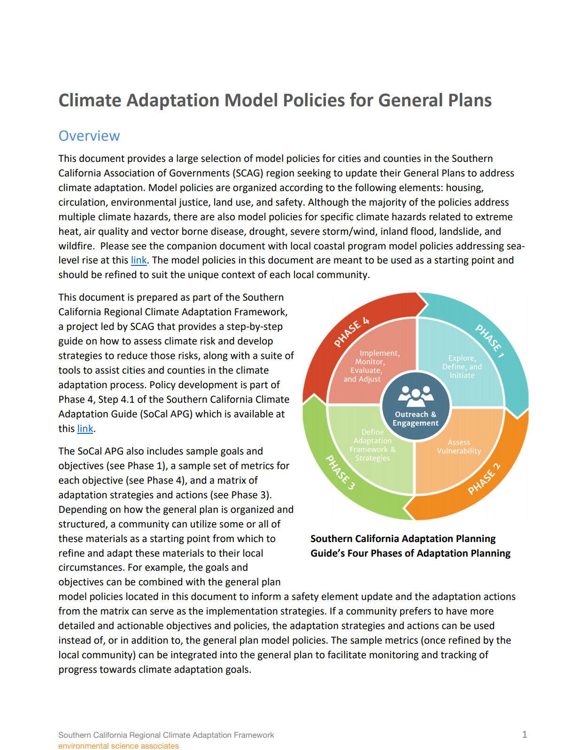 | Climate Adaptation Model Policies for General Plans (SCAG, 2020)*  This list provides a selection of 103 model adaption policies intended for cities and counties seeking to incorporate resilience into any General Plan element or other planning document. Model policies are organized by general plan elements: housing, circulation, environmental justice, land use, and safety; and address climate change hazards related to extreme heat, drought, severe storm/wind, inland flood, landslide, wildfire, air quality and vector borne disease.
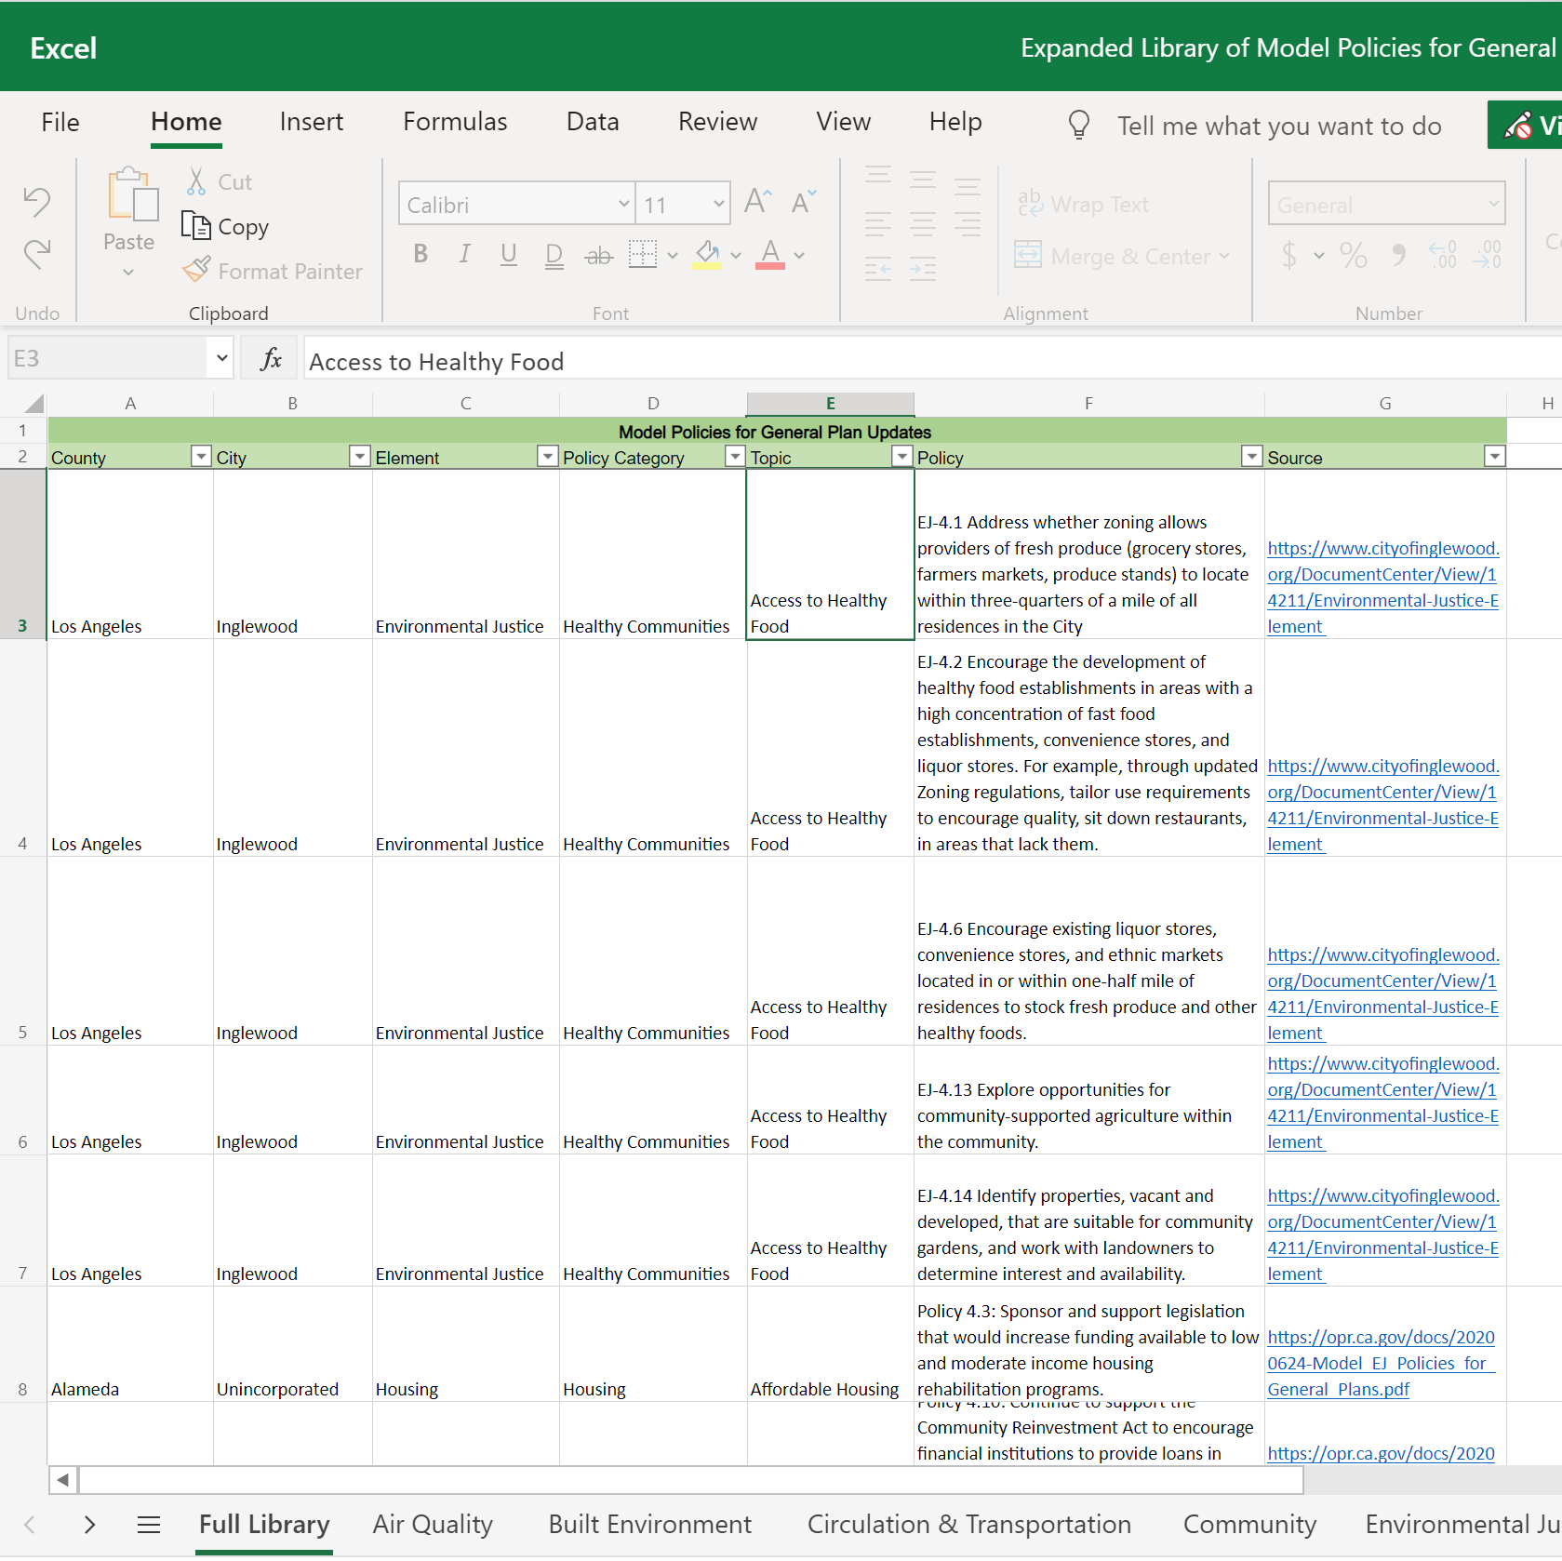 | Expanded Library of Model Policies for General PlansClimate Adaptation Model Policies - Extended Policies (SCAG, 2020)  This extensive inventory organizes over 1,600 policies for use across 13 General Plan elements including housing, safety, and environmental justice. The inventory includes the climate adaptation model polices (above) and adds many example policies from jurisdictions across the state and OPR’s Environmental Justice model policies. The policies are organized in an excel table by element with searchable columns to filter policies by topic area.
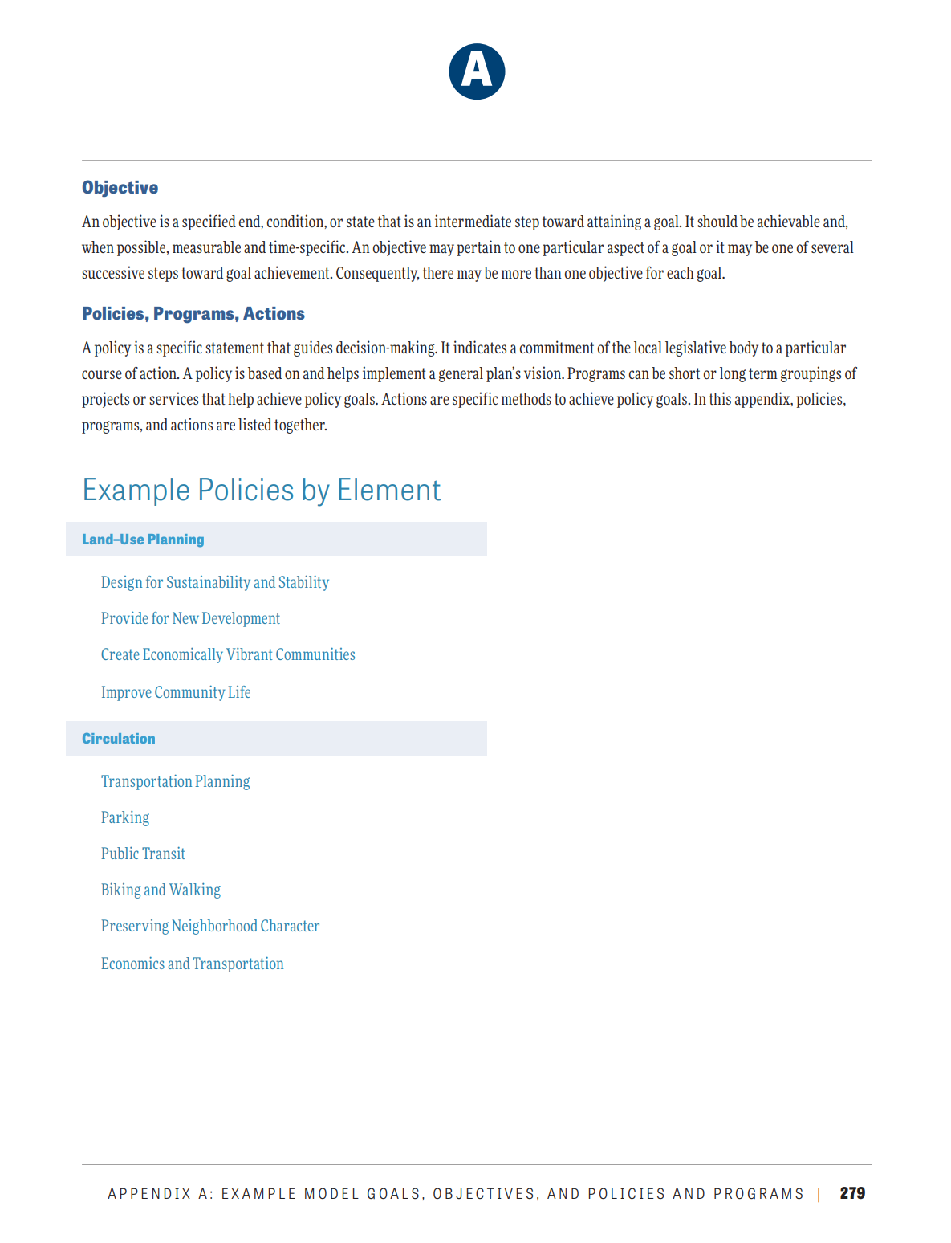 | General Plan Guidelines: App. A - Example Model Policies… (OPR, 2017)*  OPR published a set of model policies developed through public outreach, stakeholder engagement, expert input, and independent research. They are organized by general plan element, with policies grouped by topic area consistent with the general plan sections. Resilience policies can primarily be found in the safety, healthy communities, and climate change element sections.
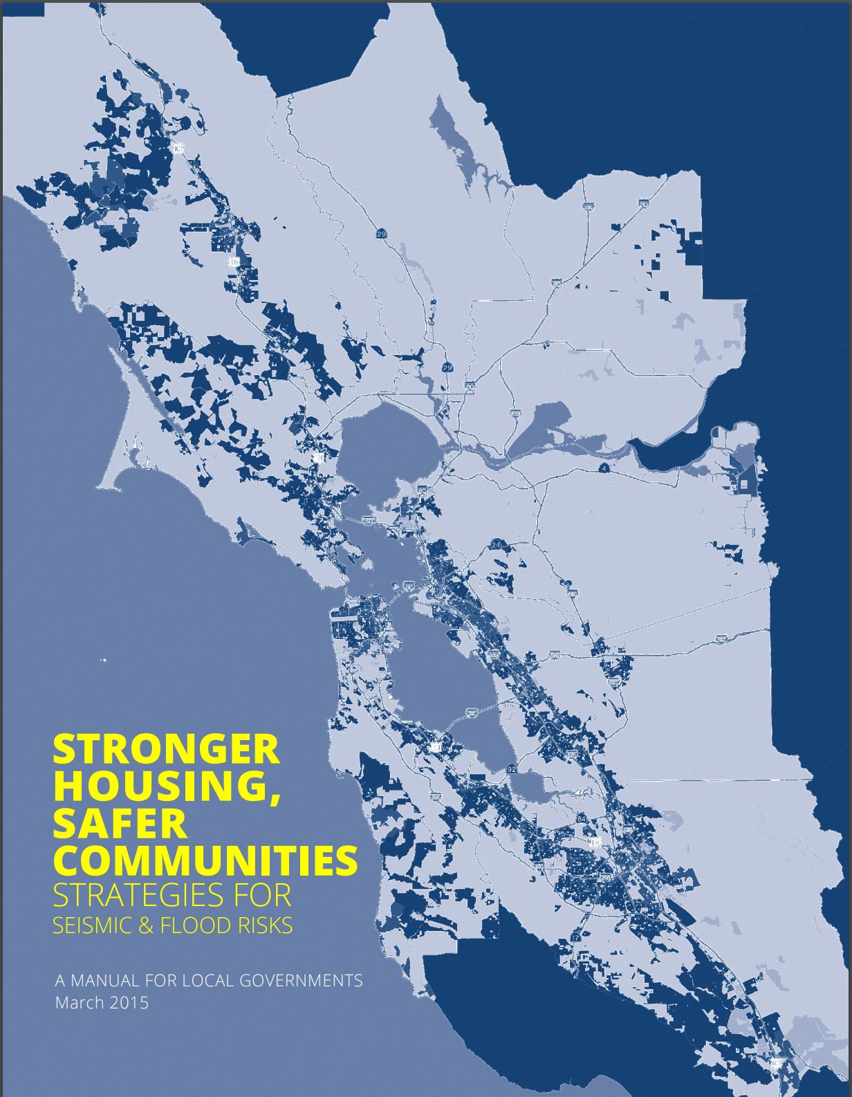 | Stronger Housing Safer Communities Strategies (ABAG & BCDC, 2015)*  This manual provides locally relevant strategies to address housing and community challenges to seismic and flooding risk. These strategies cover topics like reducing development in the highest hazard areas, retrofitting fragile housing in seismic hazard areas, increasing building standards for new construction in hazard zones, financing mechanisms, preparing for post-disaster recovery, and coordination with non-profits and community organizations.
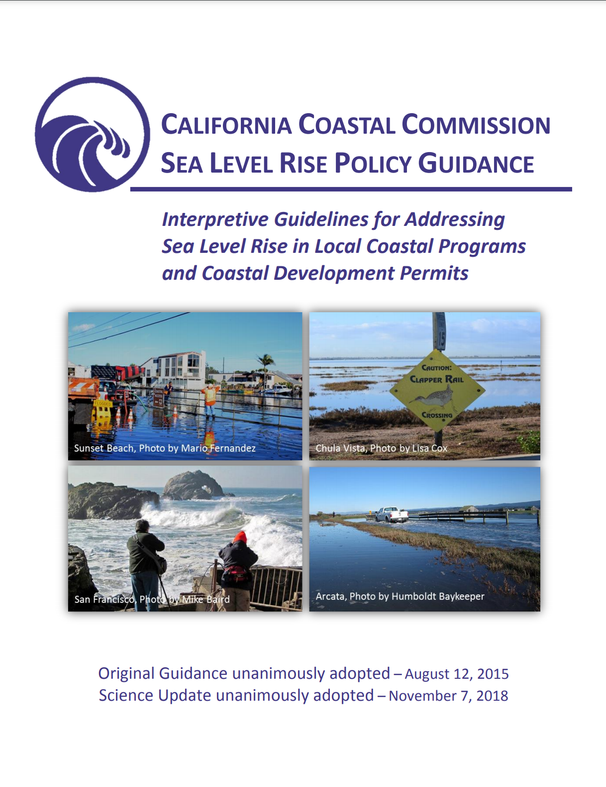 | Interpretive Guidelines for Addressing Sea Level Rise in Local Coastal Programs and Coastal Development Permits (BCDC 2018)  This resource sets forth broad principles related to planning for sea level rise and provides policy guidance and best practices to address challenges and advance adaptation. The resource provides examples roughly 150 policies. This guidance is consistent with statewide initiatives to address climate change and sea level rise including: Safeguarding California (2015), California Adaptation Strategy (2009), and the General Plan Guidelines (2017).
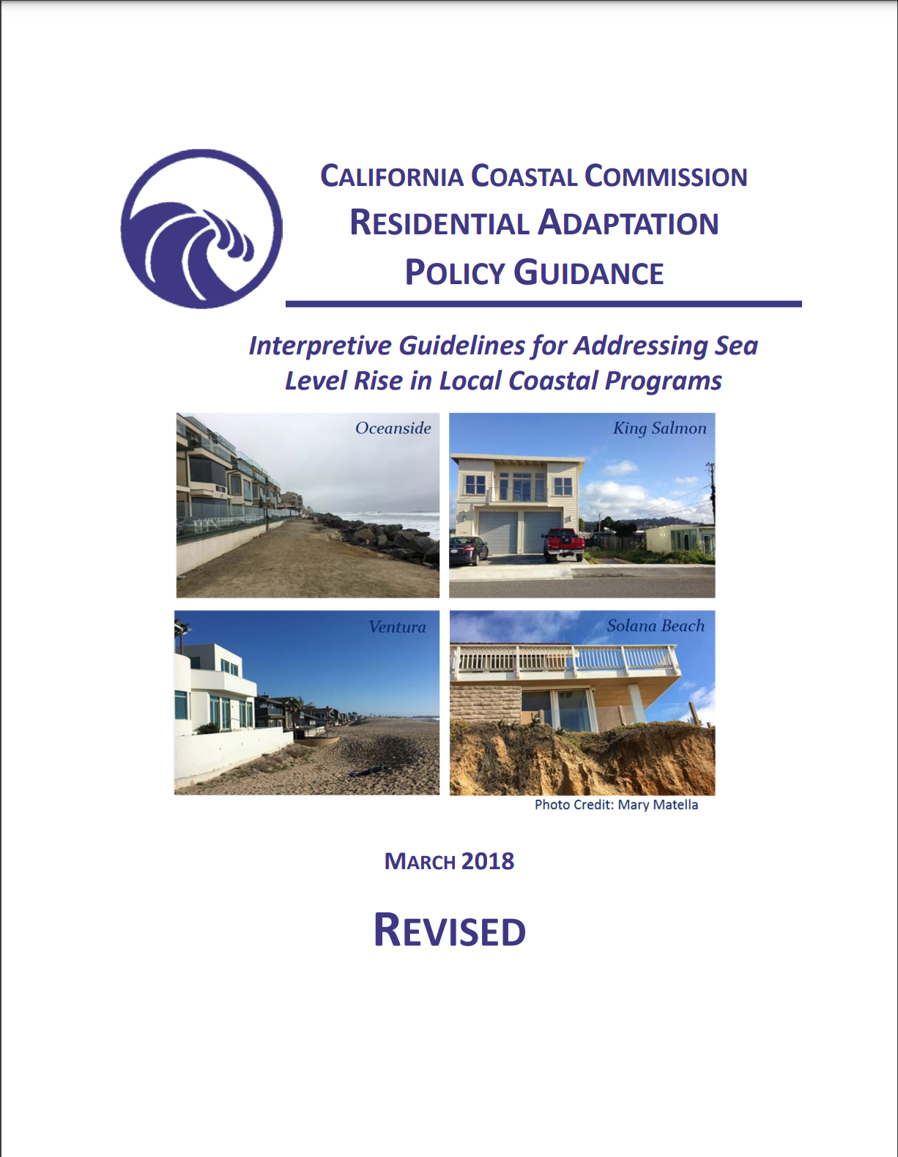 | Residential Adaptation Policy Guidance (CCC, 2018)*  This guidance is a companion document to the other CCC resource above. This Guidance provides an in-depth discussion of 50 sea level rise adaptation policies specifically related to residential development, and it provides model language that cities and counties can modify to fit their local conditions. The model policy language is organized by five adaptation approaches: avoid, accommodate, managed realignment, soft or natural protection, and hard protection. This guide is currently in draft form as of the writing of this document.
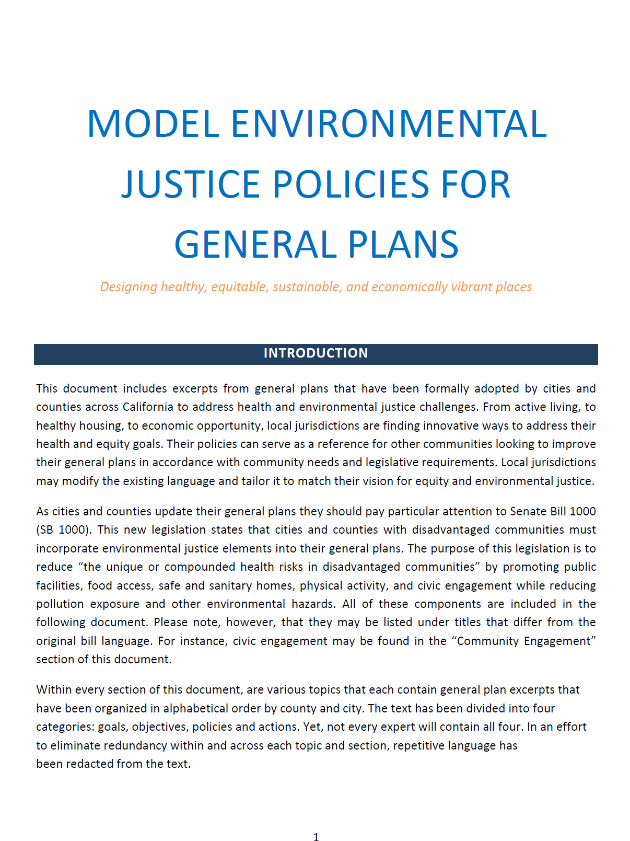 | OPR Model EJ Policies for General Plans (OPR, 2020)  This resource contains hundreds of general plan policies that have been adopted by cities and counties across California to address health and environmental challenges. The guidance is consistent with SB 1000 requirements for general plans regarding disadvantaged communities and EJ elements. Jurisdictions may consider aligning SB 1000 plan requirements with other state adaptation and housing requirements, specifically around vulnerable communities.
2021 State of ART Adaptation Catalogue (BCDC, 2021)
This resource provides an overview of sea level rise and flooding adaptation actions. The Catalog is divided into five sections: Plans & Policies, Capacity Building, Programs & Operations, Build a Project, and Funding & Financing Mechanisms. Additionally, there are Education and Outreach and Coordination tabs with suggestions for innovative ways to engage, educate, and coordinate with local stakeholders throughout the planning process. This resource is in draft form with an expected public released in late summer 2021.
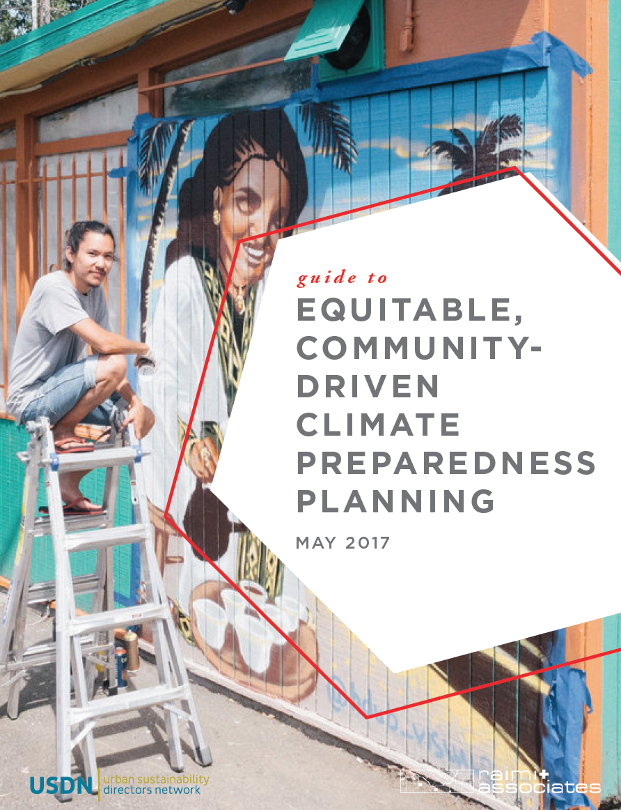 | Equitable Community Driven Climate Preparedness Plan… (USDN, 2017)  The guide outlines a framework for a community-driven, equitable climate preparedness planning process. Chapter 4 presents policy options across four categories: 1) extreme heat, 2) urban and coastal flooding, 3) wildfires and air quality, and 4) rising utility and food costs. For each, common adaptation strategies are identified and adjusted to advance equity. Table 8 starting on pg. 57 summarizes the strategies and when available, includes case study examples.

Credits
Association of Bay Area Governments Project Staff
Carrie Simmons AmeriCorps CivicSpark Resilience Fellow
Michael Germeraad Resilience Planner
Rachael Hartofelis Resilience Planner

This technical assistance document was produced with financial support from FEMA.
Our special thanks to feedback from Jaclyn Mendoske of San Francisco Bay Conservation and Development Commission (BCDC), Karen Tanner of BCDC, Dana Brechwald of BCDC, Daniel Saver of ABAG, Ada Chan of ABAG, Somaya Abdelgany of ABAG, Zoe Siegel of Greenbelt Alliance, Eli Kaplan of ABAG, Jennifer Berg of Bay Area Regional Energy Network, Rob Olshansky, Molly Mowery, David Driskell, and Marcus Griswold.

End Notes

Planning for Equity Policy Guide – American Planning Association (2019) https://planning-org-uploaded-media.s3.amazonaws.com/publication/download_pdf/Planning-for-Equity-Policy-Guide-rev.pdf
Integration Concepts for General Plan Updates or other Local Planning– Housing and Community Development (2020) https://www.hcd.ca.gov/grants-funding/active-funding/leap/docs/planning%20integration%20concepts_v4.pdf
Defining Vulnerable Communities in the Context of Climate Change – Office of Planning and Research (2018) https://opr.ca.gov/docs/20200720-Vulnerable_Communities.pdf
Strategic Plan to Protect California’s Coast and Ocean 2020-2025, California Ocean Protection Council (2020) https://www.opc.ca.gov/webmaster/ftp/pdf/2020-2025-strategic-plan/OPC-2020-2025-Strategic-Plan-FINAL-20200228.pdf
State of California – Sea Level Rise Guidance, California Natural Resources Agency & California Ocean Protection Council (2018) https://opc.ca.gov/webmaster/ftp/pdf/agenda_items/20180314/Item3_Exhibit-A_OPC_SLR_Guidance-rd3.pdf
City of Berkley City Manager’s Office Website Pos dated July 27, 2020. https://www.cityofberkeley.info/City_Manager/Press_Releases/2017/2017-07-27_Join_Police_Fire_and_City_Staff_for_National_Night_Out.aspx
Local Climate Snapshot Tool, CalAdapt (2021) https://cal-adapt.org/tools/local-climate-change-snapshot/
Green & Healthy Homes, Marin Community Foundation https://www.marincf.org/buck-family-fund-grants/environment/green-healthy-homes
County of Sonoma, General Services, Energy and Sustainability Website Post; January 7, 2020 https://sonomacounty.ca.gov/General-Services/Energy-and-Sustainability/Press-Releases/Financing-Program-for-Wildfire-Safety-and-Seismic-Improvements/
Wetlands Watch https://wetlandswatch.org/soft-armoring https://wetlandswatch.org/hard-armoring
Property Topics and Concepts – American Planning Association (2007) https://www.planning.org/divisions/planningandlaw/propertytopics.htm#:~:text=the%20public%20interest.-,Overlay%20Zones,of%20the%20underlying%20zoning%20district.
Lot Line Adjustment City of Oceanside https://www.ci.oceanside.ca.us/gov/dev/eng/forms/lla.asp#:~:text=A%20lot%20line%20adjustment%20is,existed%20are%20not%20thereby%20created. https://www.ci.oceanside.ca.us/gov/dev/eng/forms/lla.asp#:~:text=A%20lot%20line%20adjustment%20is,existed%20are%20not%20thereby%20created.
Rolling Easements – Environmental Protection Agency (2011) https://www.epa.gov/sites/production/files/documents/rollingeasementsprimer.pdf
Transfer of Development Rights – Planning for Hazards https://www.planningforhazards.com/transfer-development-rights-tdrs
City of Pacifica’s Local Coastal Plan certification draft (March 2020) https://cityofpacifica.egnyte.com/dl/EPskSdDwa4/?
Managed Retreat toolkit - Georgetown Climate Center (2020) https://www.georgetownclimate.org/adaptation/toolkits/managed-retreat-toolkit/introduction.html?chapter#:~:text=Under%20the%20best%20of%20circumstances,individual%20people%2C%20communities%2C%20and%20ecosystems
Guidance for Severe Repetitive Loss Properties – FEMA (2011) https://www.fema.gov/pdf/nfip/manual201205/content/20_srl.pdf
Nonconforming Uses, Structures, and Lots – Municipal Research Services Center (2021) http://mrsc.org/Home/Explore-Topics/Planning/Development-Regulations/Nonconforming-Uses-Structures-and-Lots-Regulatio.aspx
Fire Hazard Planning Technical Advisory – Office of Planning and Research (2020) https://opr.ca.gov/docs/20201109-Draft_Wildfire_TA.pdf
Drainage Criteria Manual (v.2) - California State Water Board (2001) https://www.waterboards.ca.gov/rwqcb2/water_issues/programs/stormwater/muni/nrdc/11%20chapter%2011%20flood%20proofing.pdf
Flood Building Codes - Federal Emergency Management Agency https://www.fema.gov/emergency-managers/risk-management/building-science/building-codes/flood
Urban Runoff: Low Impact Development – Environmental Protection Agency https://www.epa.gov/nps/urban-runoff-low-impact-development#:~:text=The%20term%20low%20impact%20development,quality%20and%20associated%20aquatic%20habitat.
Affordable Housing and Sustainable Communities Program – Round 6 FY 2019-2020 Program Guidelines https://sgc.ca.gov/meetings/council/2021/docs/20210224-AHSC_Round_6_Guidelines.pdf
Wildland-Urban Interface (WUI) Areas – Housing and Community Development https://www.hcd.ca.gov/building-standards/state-housing-law/wildland-urban-interface.shtml
City of Santa Rosa, Community Wildfire Protection Plan (2020) https://srcity.org/DocumentCenter/View/30136/City-of-Santa-Rosa-Community-Wildfire-Protection-Plan-CWPP_91820
California Green Building Standards Code – California Building Standards Commission (2019) https://calgreenenergyservices.com/wp/wp-content/uploads/2019_california_green_code.pdf
Water Upgrades Save Program Website, BayRen https://www.bayren.org/waterupgradessave
Greywater Rebate Program, Valley Water https://www.valleywater.org/saving-water/rebates-surveys/graywater-rebate
A Roadmap to Decarbonize California Buildings – Building Decarbonization Coalition (2019) https://www.buildingdecarb.org/uploads/3/0/7/3/30734489/bdc_roadmap_2_12_19.pdf
Access & Functional Needs – California Office of Emergency Services https://www.caloes.ca.gov/cal-oes-divisions/access-functional-needs#:~:text=Access%20and%20functional%20needs%20(AFN)%20refers%20to%20individuals%20who%20are,Older%20adults
Vapor Intrusion Technical Guide – Environmental Protection Agency (2015) https://www.epa.gov/sites/production/files/2015-09/documents/oswer-vapor-intrusion-technical-guide-final.pdf
Disaster Mitigation Technical Support – California Office of Emergency Services https://www.caloes.ca.gov/cal-oes-divisions/recovery/disaster-mitigation-technical-support/technical-assistance/debris-management
County of San Mateo Health, Removal of Ash and Debris https://www.smchealth.org/post/phase-ii-removal-ash-and-debris
California Civil Code Article 1.7. Disclosure of Natural and Environmental Hazards, Right-to-Farm, and Other Disclosures Upon Transfer of Residential Property [1103 - 1103.15] (2018) https://leginfo.legislature.ca.gov/faces/codes_displaySection.xhtml?sectionNum=1103.2.&lawCode=CIV

