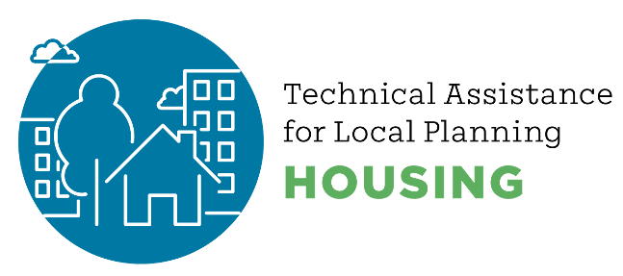
What is a Housing Element?
A Housing Element is how local jurisdictions plan to meet the housing needs of everyone in the community. At its core a Housing Element is an opportunity to have a community conversation about how to address local housing challenges and find solutions. The Housing Element is one important part of a city or county’s General Plan, which serves as the blueprint for how a city or county will grow and address changing needs for development. Every eight years, every city, town and county must update their Housing Element and have it certified by the California Department of Housing and Community Development.

- State law does not require that jurisdictions build or finance new housing, but they must plan for it.
- Every city in California receives a target number of homes to plan for. This is called the Regional Housing Needs Allocation or RHNA.
- The state of California determines the number of new homes the Bay Area needs to plan for – and how affordable those homes need to be – in order to meet the housing needs of people at all income levels.
- The Association of Bay Area Governments convened diverse stakeholders in a Housing Methodology Committee to distribute the region’s housing allocation to each jurisdiction in the Bay Area.
- Housing elements must be updated every eight years and must be certified by the California Department of Housing and Community Development.
A Housing Element is a local plan, adopted by a city, town or county that includes the goals, policies and programs that direct decision-making around housing.
All jurisdictions in the Bay Area must update their Housing Element for the 2023-2031 planning period. Local jurisdictions look at housing trends, zoning and market constraints, and evaluate various approaches to meeting housing needs across income levels.
The Inventory of Available Sites, or “Sites Inventory,” is a key component of a Housing Element where jurisdictions identify if they have enough land zoned for housing to meet the future need.
Local governments must involve the public from all economic segments of the community in developing the Housing Element.

What Are the Components of a Housing Element?

The Housing Element typically includes:
- Housing Needs Assessment: Examine demographic, employment and housing trends and conditions that affect the housing needs of the community.
- Evaluation of Past Performance: Review the prior Housing Element to measure progress in implementing policies and programs.
- Housing Sites Inventory: Identify locations of available sites for housing development or redevelopment to ensure that there is adequate capacity to address the Regional Housing Needs Allocation.
- Community Outreach and Engagement: Implement a robust community outreach and engagement program, with a particular focus on outreach to traditionally underrepresented groups.
- Constraints Analysis: Analyze and recommend remedies for existing and potential governmental and nongovernmental barriers to housing development.
- Policies and Programs: Establish policies and programs to fulfill the identified housing needs.

What Happens if a Jurisdiction Does Not Adopt a Housing Element?
If a city does not comply with State law, it can be sued. In addition to facing significant fines, a court may limit local land use decision-making authority until the jurisdiction brings its Housing Element into compliance. Additionally, local governments may lose the right to deny certain projects. These and other consequences are established in state law; Housing Elements are subject to regulatory oversight by the California Department of Housing and Community Development. ABAG does not play a direct role in regulating local Housing Elements.


2.18.2021

