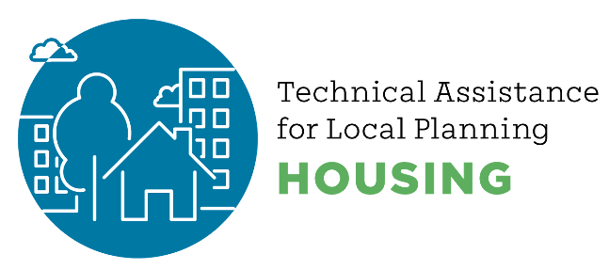
Communications Tips for Housing Staff

Use personal stories in presentations
A story of a resident trying to find housing for their children or grandchildren at the beginning of a public meeting can make meetings more relatable

Consider order of presentation and public comments

Use demographics

Home owners say this, renters say that…

Use “homes” not “units”

Dr. Tiffany Manuel says:

- Narrative functions as part of housing
- Storytelling Animal
- Nature of who we are, stories take shape as then its narrative
- Who we think we are
- Narratives dominant as we hear them from the beginning of life
- Cognition way that our brains function, we don’t process information instant reaction instead
- Narrative of dominant narrative – those about affordable housing often fail
- Reframing a conversation, gets people out of those dominant narrative, without doing this then message isn’t heard

